CHAPTER IV
FINDINGS, PRESENTATION AND INTERPRETATION
This chapter presents the results of the study. It includes the hardware and software specifications of CPAce, screenshots of its major modules, the test plan and implementation plan, and the findings from the functional and performance evaluation. The findings are shown in tables and are interpreted according to the objectives stated in Chapter I.

HARDWARE SPECIFICATION
TABLE VI.
Hardware Specification of CPAce
Hardware Component | Specification
Processor | [At least 2.40 GHz]
Random Access Memory (RAM) | [At least 4 GB]
Storage | [At least 64 GB available]
Camera | Built-in or external webcam (required for proctored sessions)
Internet Connection | [At least 5 Mbps]

Table VI shows the minimum hardware needed to run CPAce. The processor and memory are enough for the adaptive quiz engine, the weakness detection computations, and the dashboards to run on the devices commonly used by students. A camera is needed only for proctored quizzes and mock examinations, where the system captures images through the browser. Since CPAce is web-based, the internet connection must be stable so that review sessions, schedules, and performance data can be accessed without interruption.

SOFTWARE SPECIFICATION
TABLE VII.
Software Specification of CPAce
Software Component | Specification
Web Browser | Google Chrome, Microsoft Edge
Operating System | Windows 10/11, Android, iOS
Web Server | Apache 2.4.58
Framework | Laravel 12
Programming Languages | PHP 8.2.12, JavaScript, HTML, CSS
Front-End Framework | Bootstrap 5
Database Management System | MySQL 8.0
Single Sign-On | Laravel Socialite (Google)
AI Service | Google Gemini API, with OpenRouter as fallback
Report Libraries | dompdf, PhpSpreadsheet, PhpWord

Table VII lists the software needed to run CPAce. The system runs on modern browsers such as Google Chrome and Microsoft Edge, which support the camera permission used by the proctoring feature. Laravel handles routing, authentication, sessions, and database access through Eloquent ORM, and the data is stored in MySQL. Students can sign in with their Google account through Laravel Socialite. The AI features send requests to the Google Gemini API, with OpenRouter as a fallback, and all AI-generated content is reviewed by the faculty or the Program Chair before it is published.

DEMONSTRATION
This section shows screenshots of the main features of CPAce. The figures are grouped by user: account access, students, faculty, the Program Chair, and the community and communication modules. Each figure shows how a feature works and how it addresses the problems described in Chapter I.
Account Access
The following figure shows how users sign in to the system.
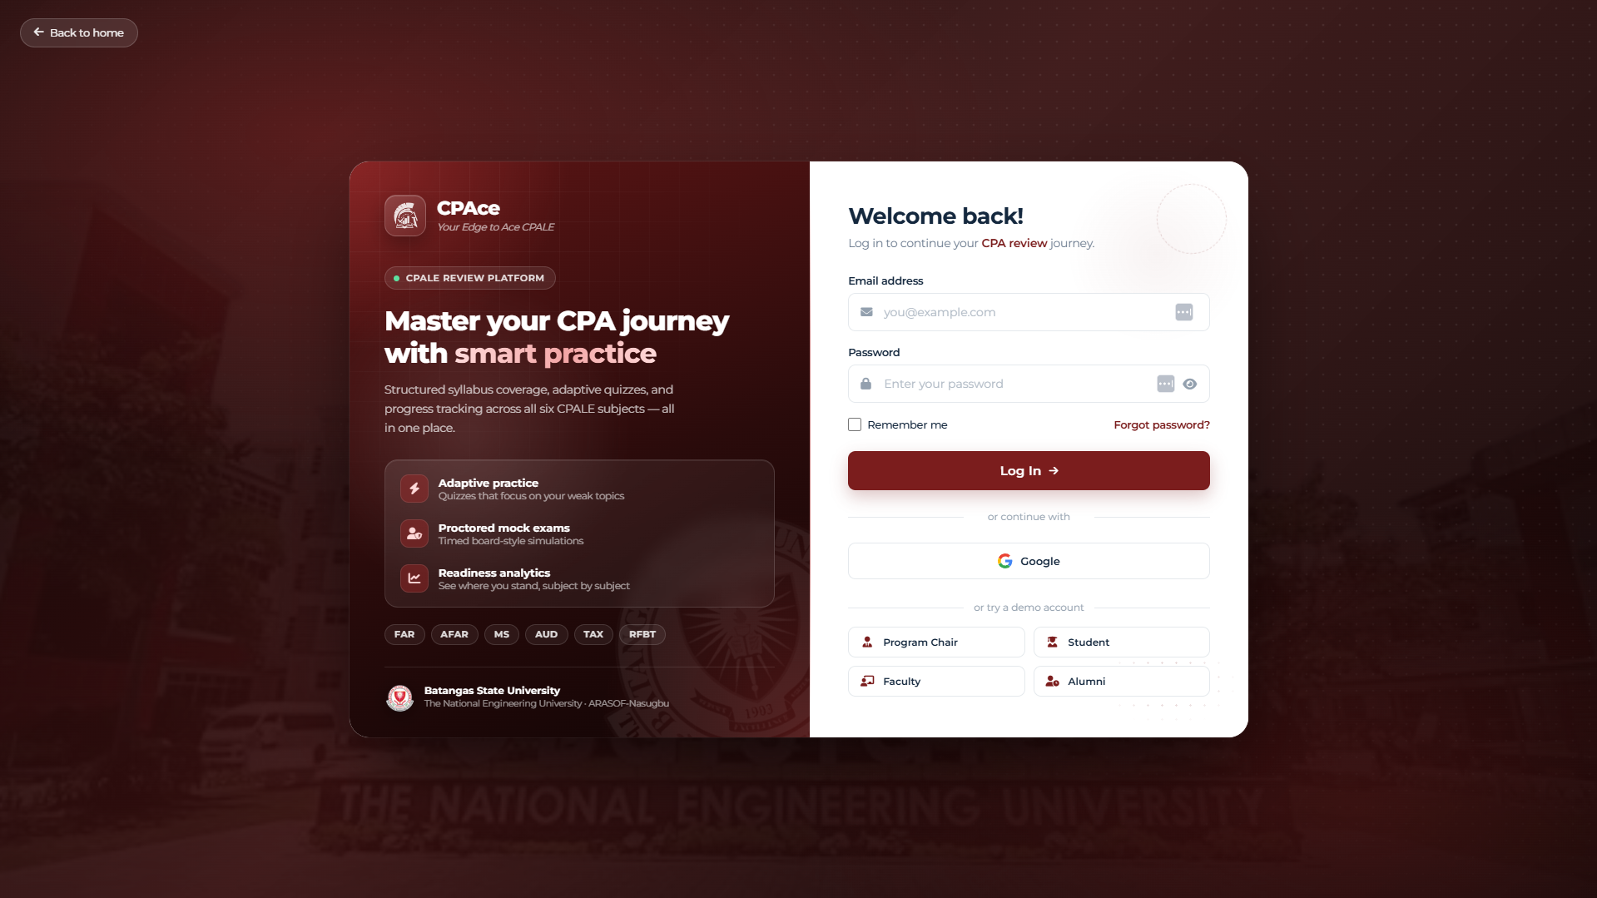
Fig. 12. Login and Google Sign-In Module
Student Modules
The following figures show the modules used by Accountancy students during their review.
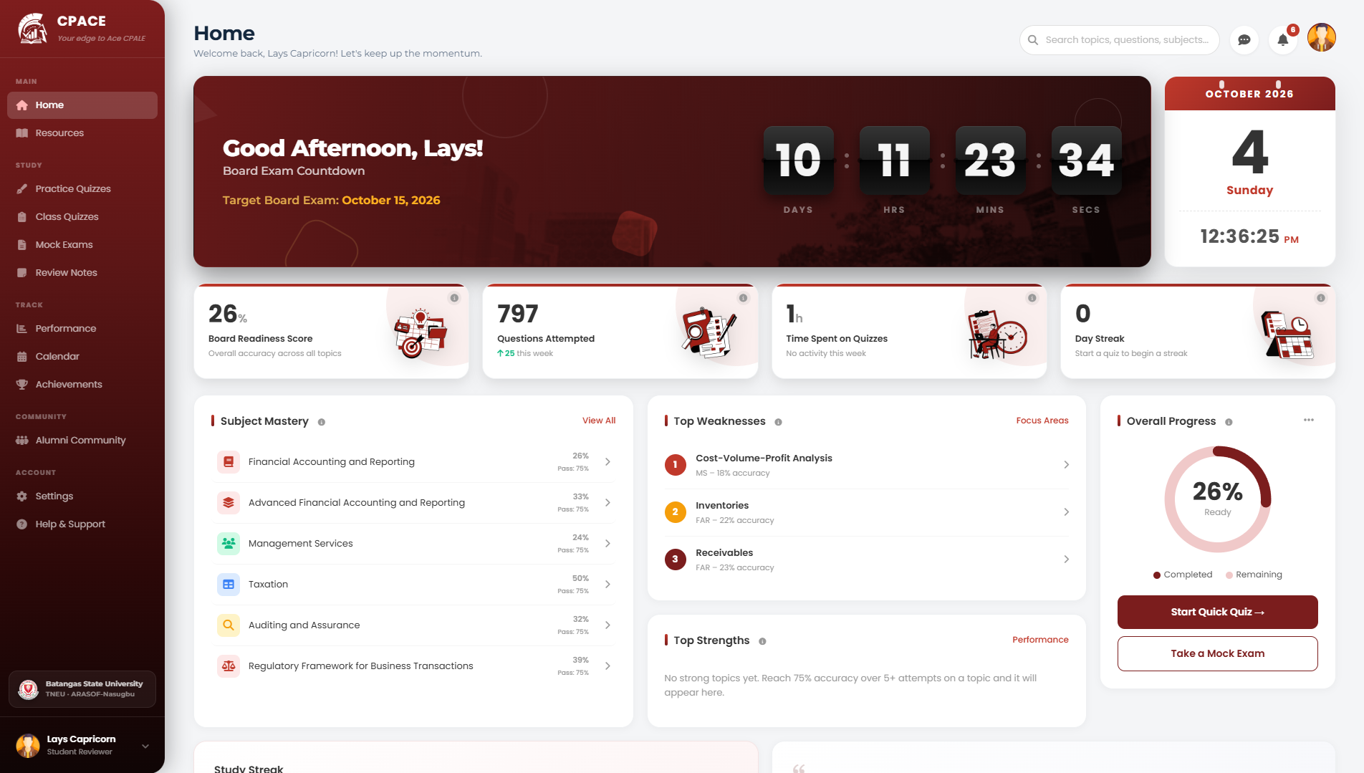
Fig. 13. Student Dashboard Module
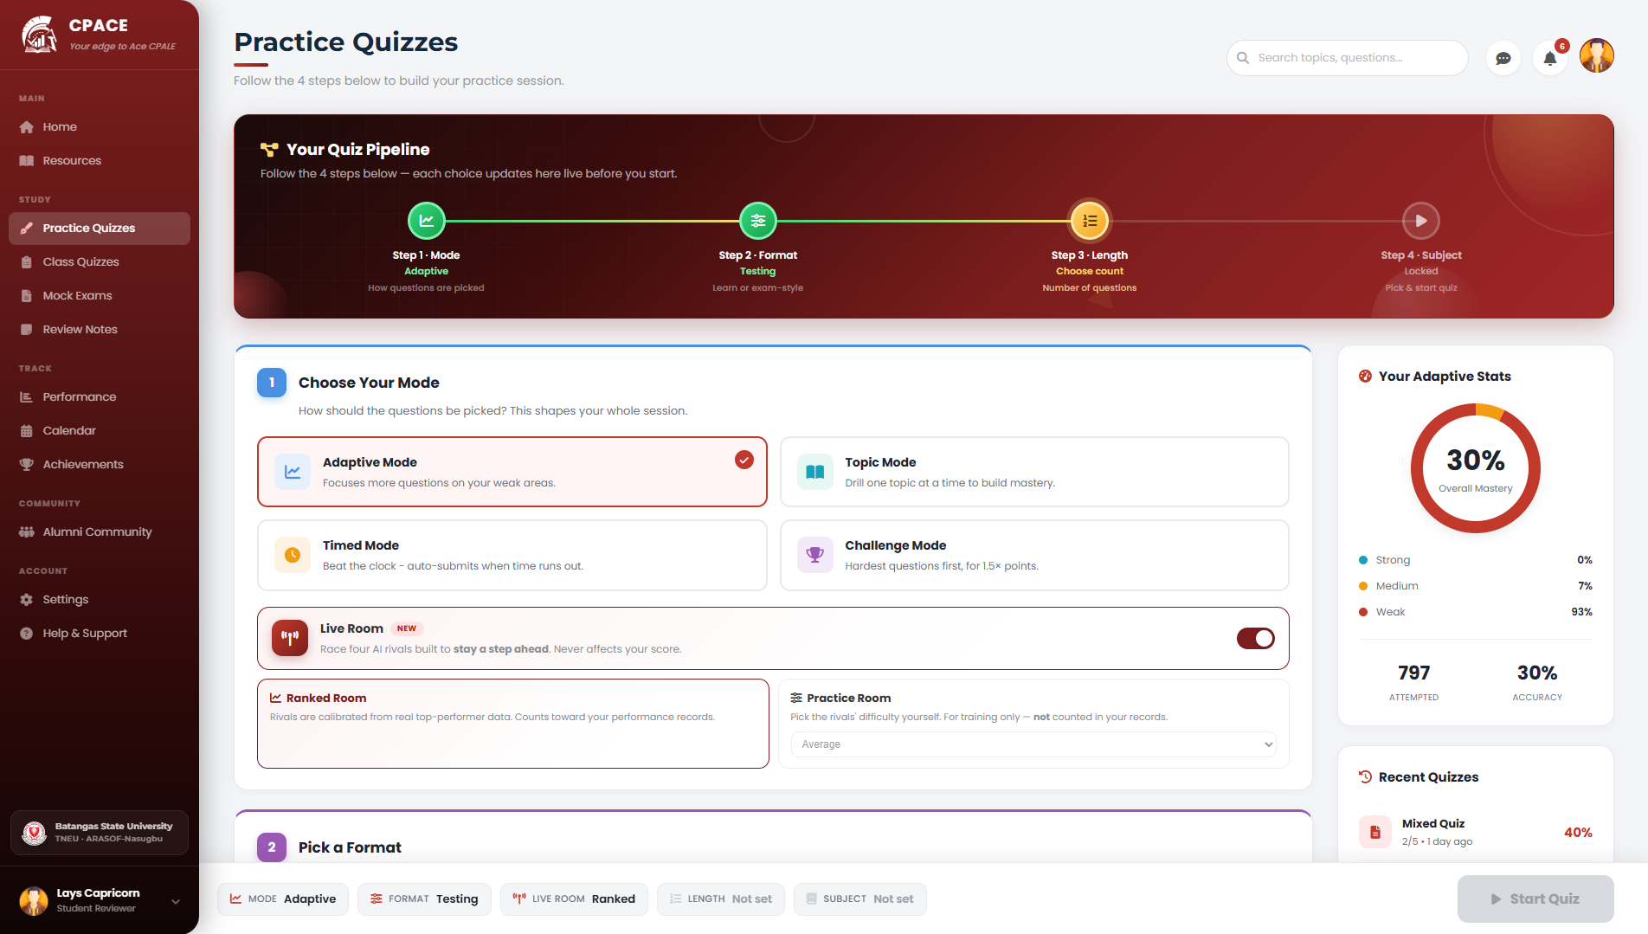
Fig. 14. Adaptive Quiz Configuration Module
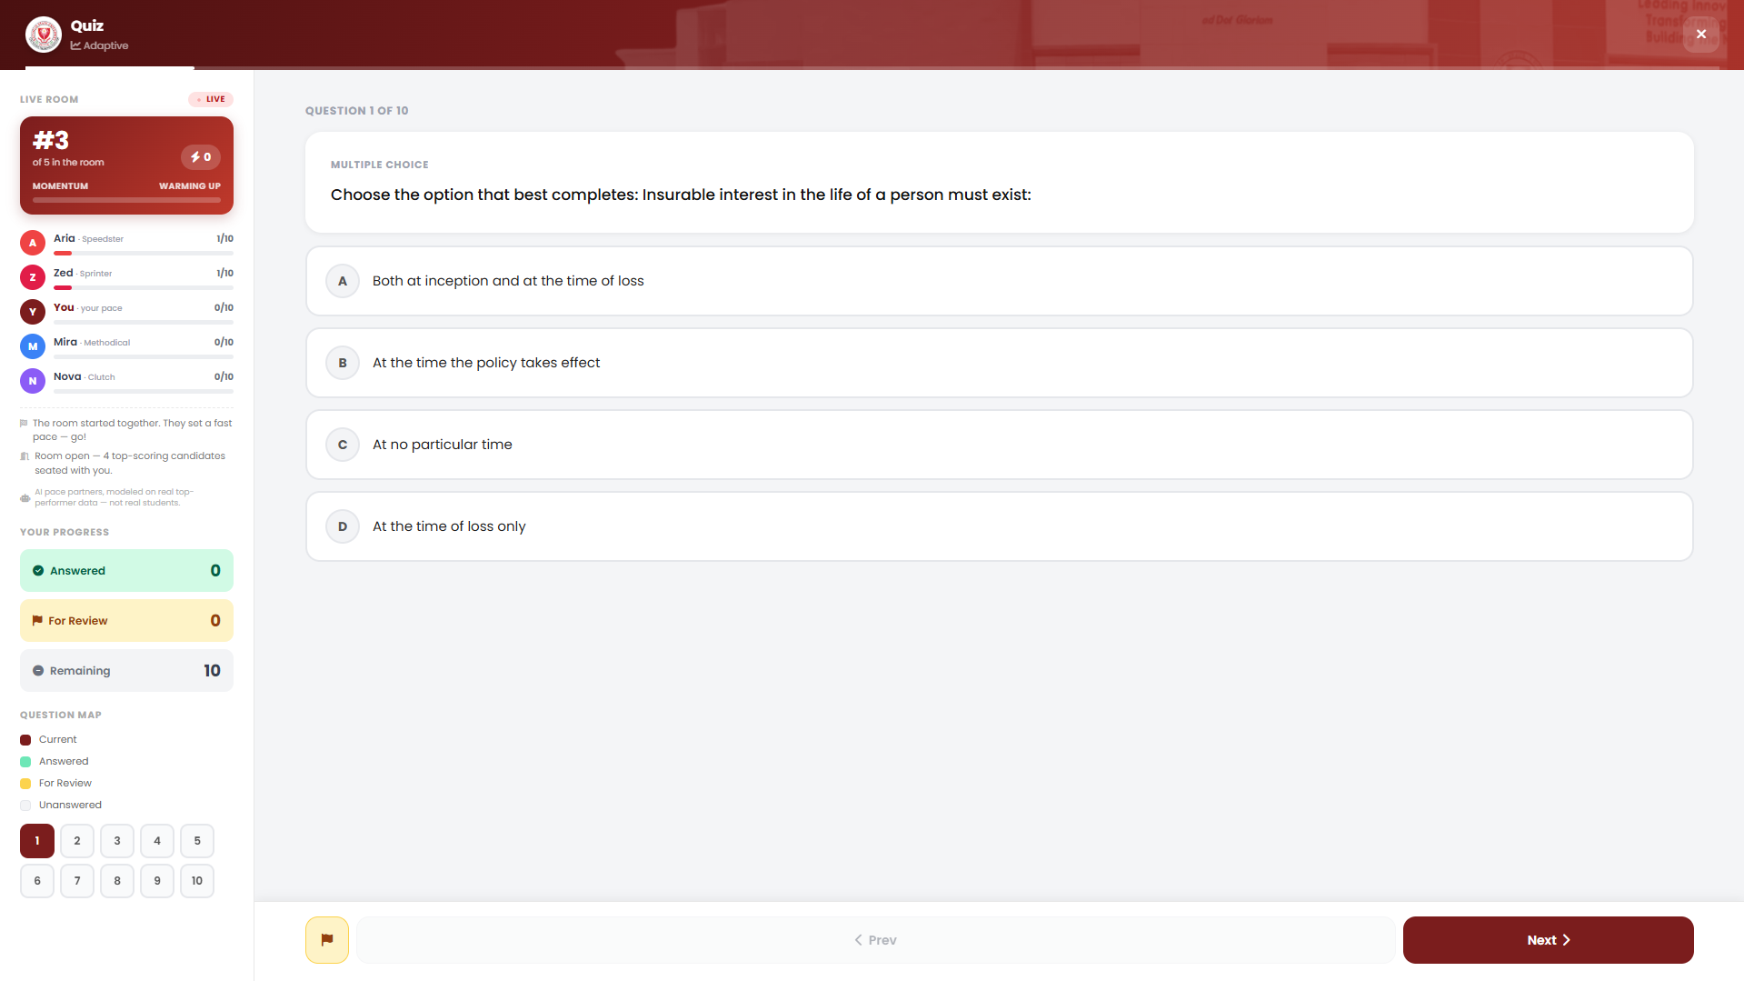
Fig. 15. Adaptive Quiz Taking Module
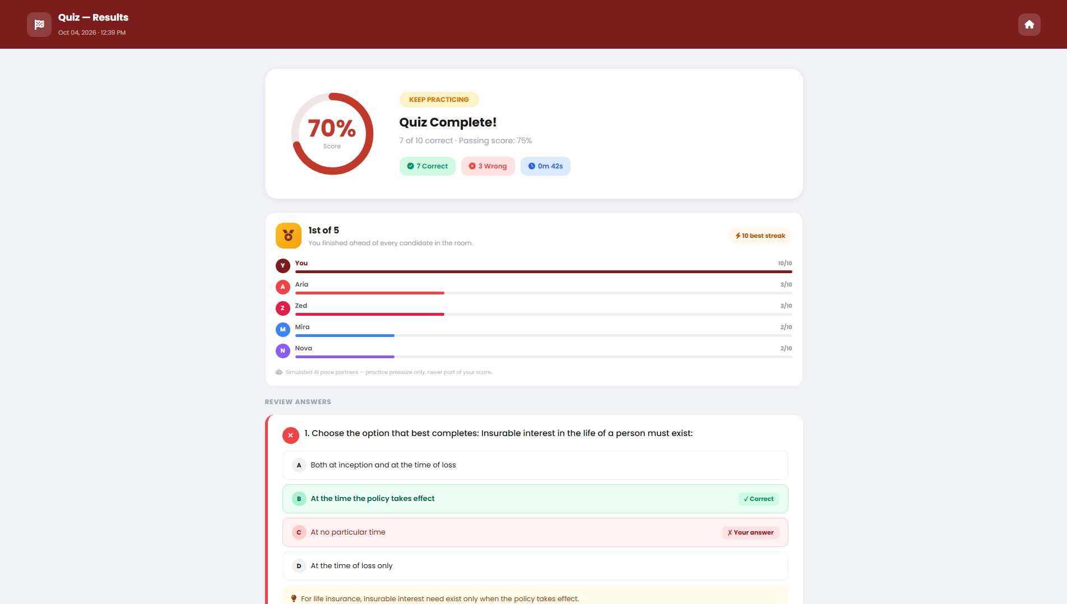
Fig. 16. Quiz Result and Item Review Module
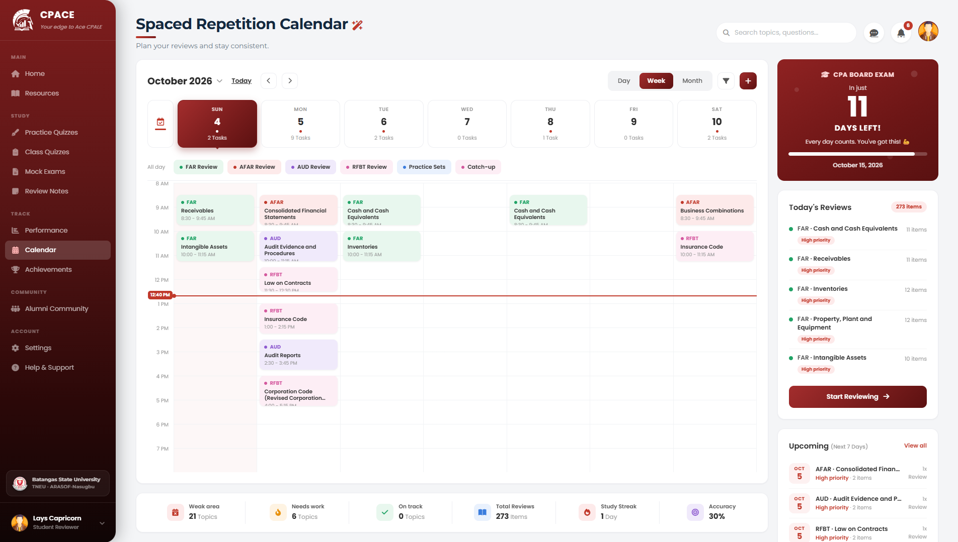
Fig. 17. Spaced Repetition Calendar Module
[Insert screenshot] (hindi ko gets need ss dine hehe)
Fig. 18. Review Schedule Detail with Days Until Next Review
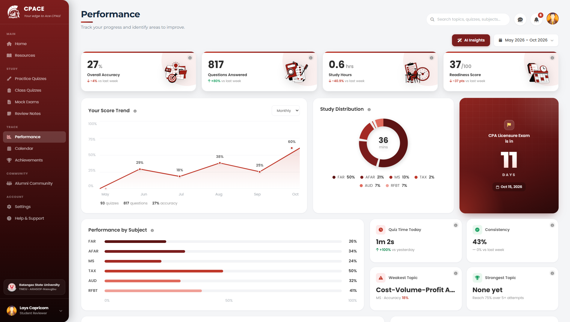
Fig. 19. Performance Dashboard Module
[Insert screenshot] (di ren hindi ko alam need ss)
Fig. 20. Subject-Level Weakness Report Module
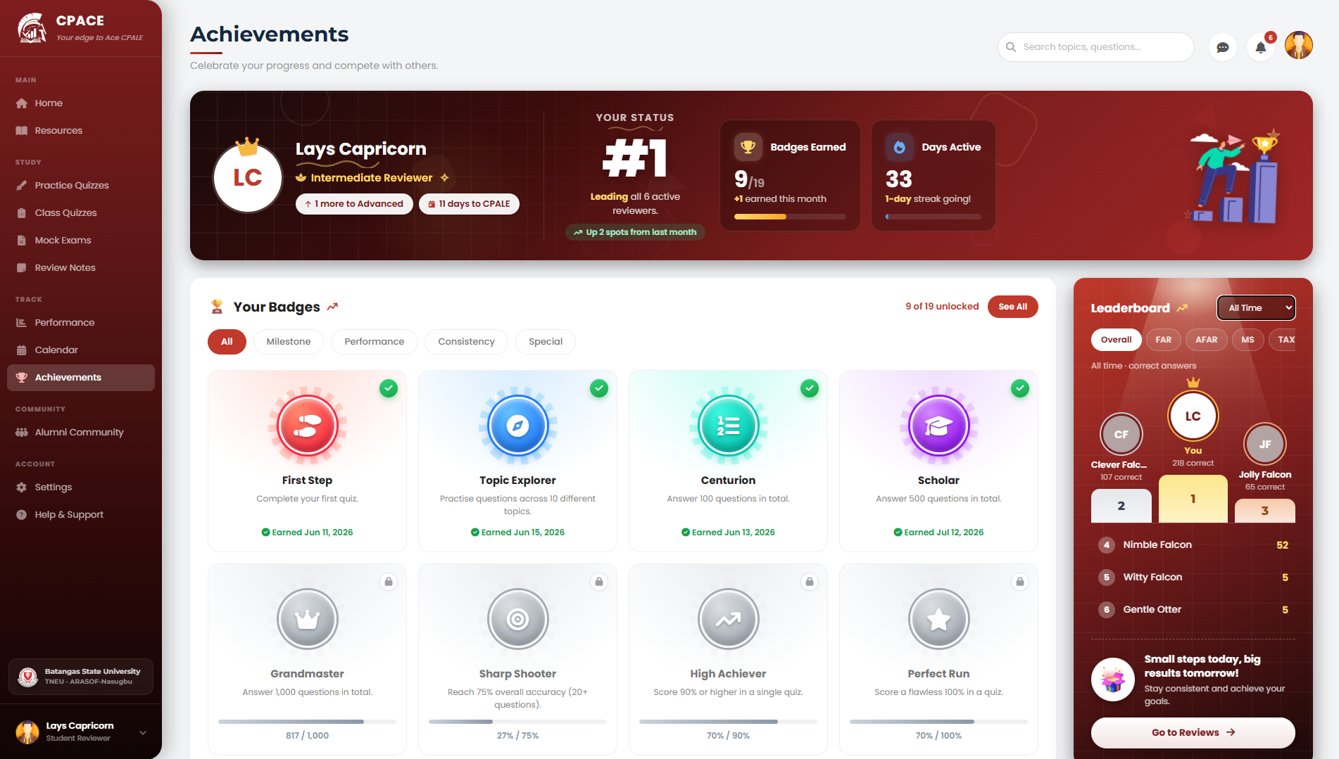
Fig. 21. Achievements and Badges Module
[Insert screenshot] (kasama na yata to sa achievement module)
Fig. 22. Leaderboard Module
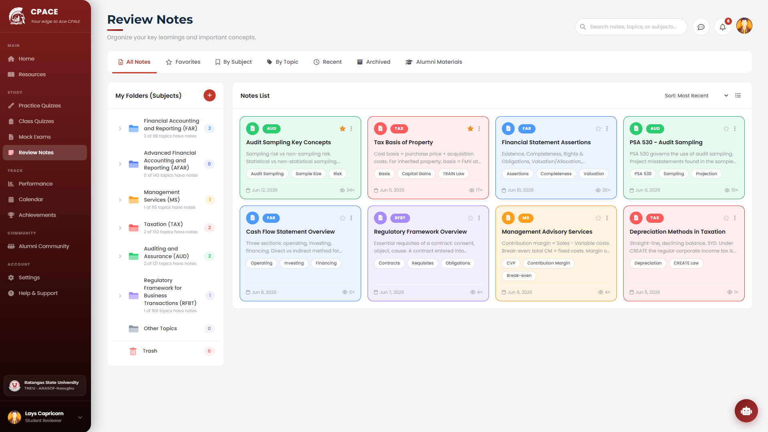
Fig. 23. Review Notes Module
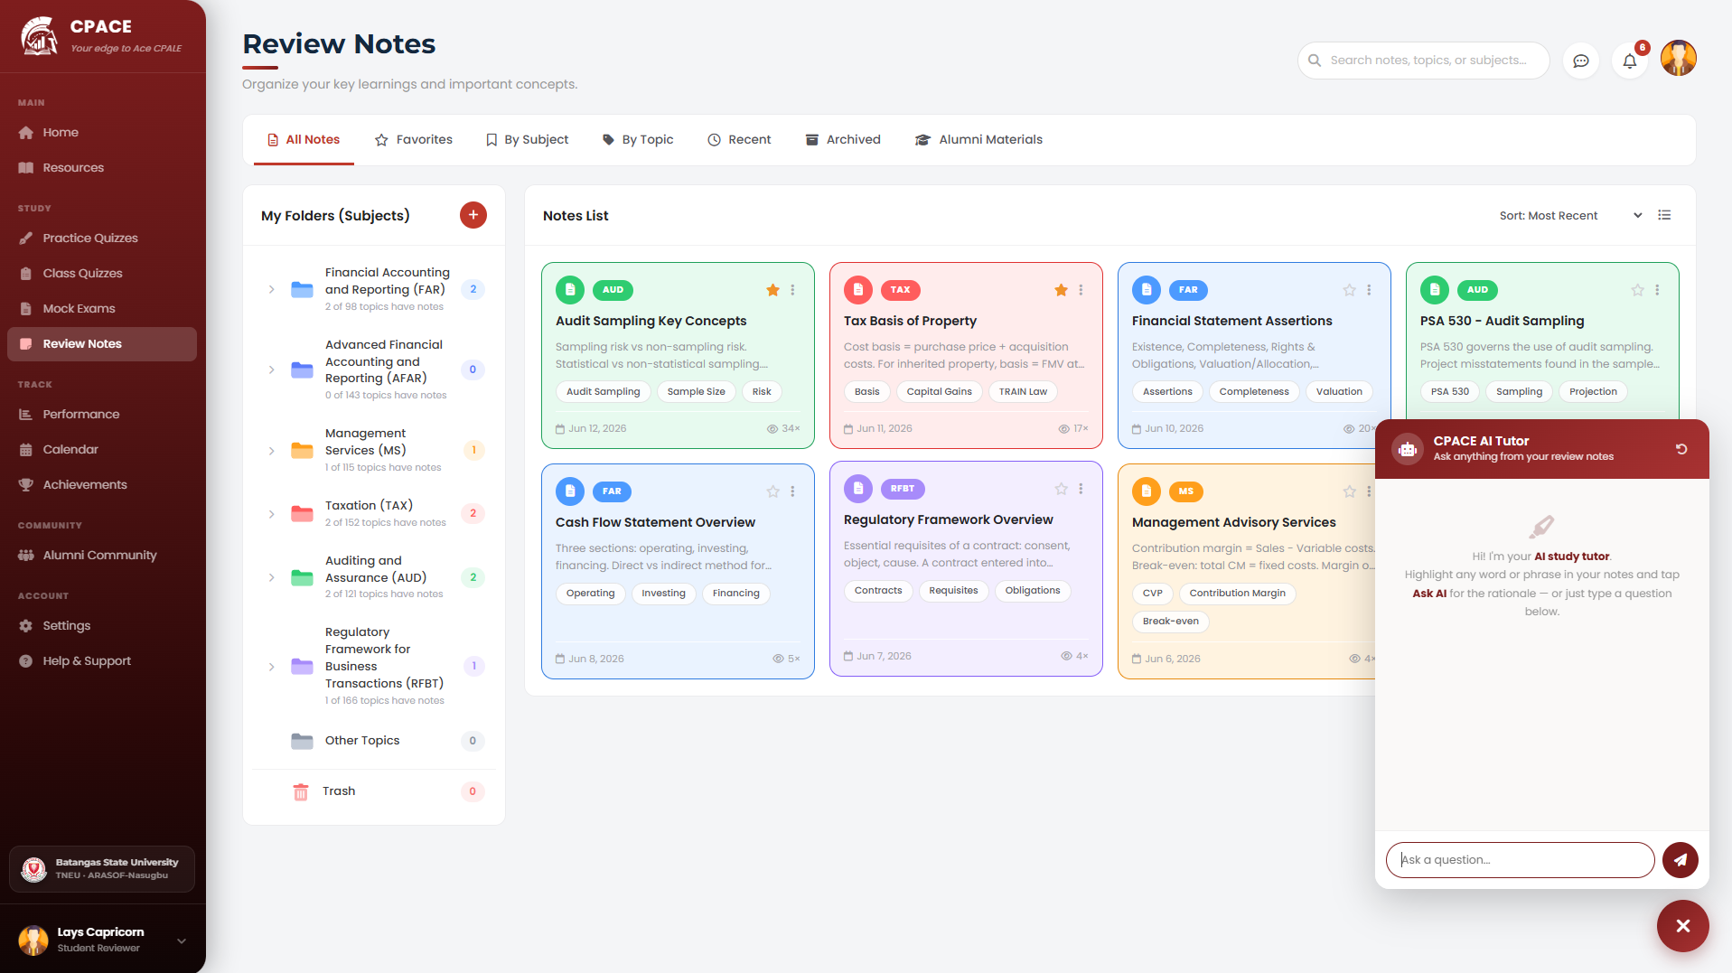
Fig. 24. AI Tutor Module
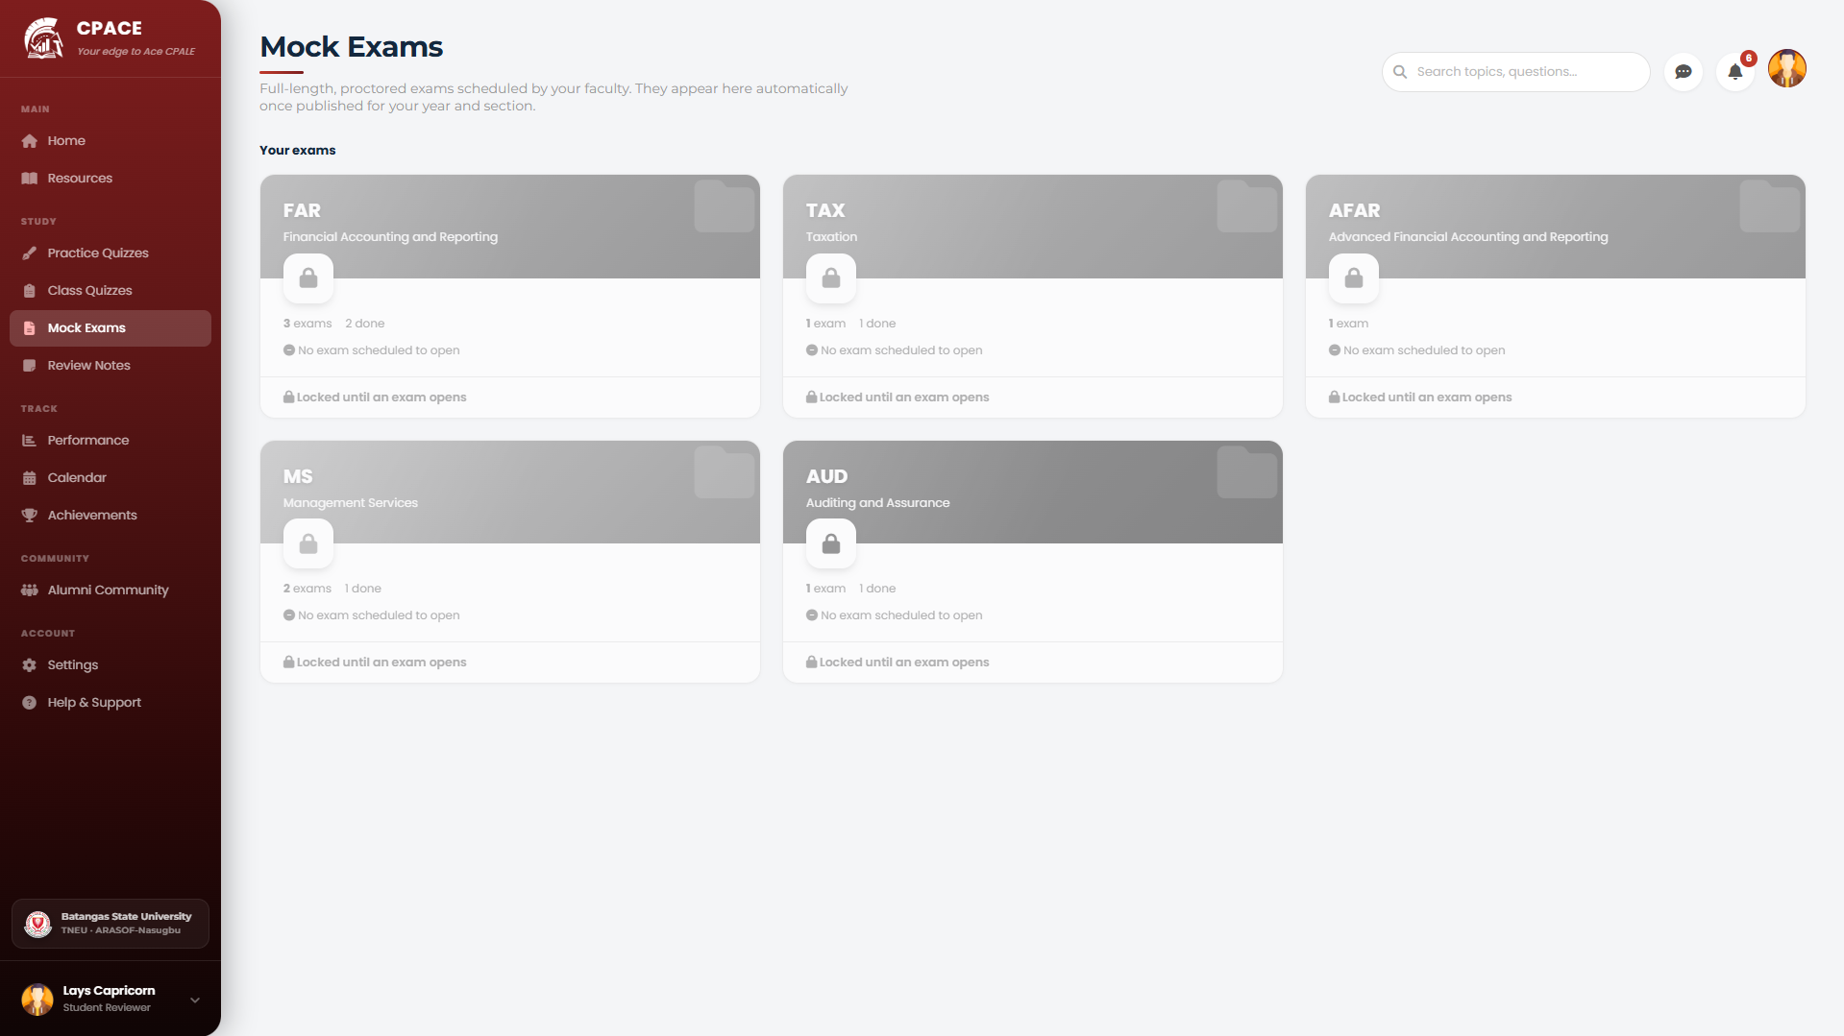
Fig. 25. Mock Examination Registration Module
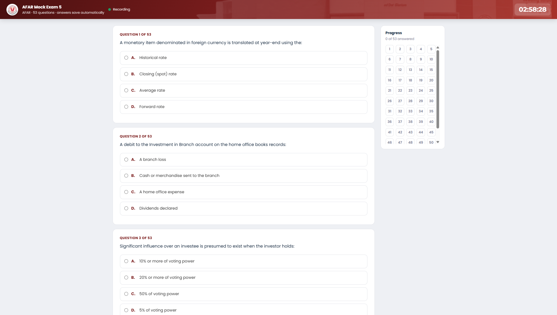
Fig. 26. Mock Examination Taking Module (Testing Mode)
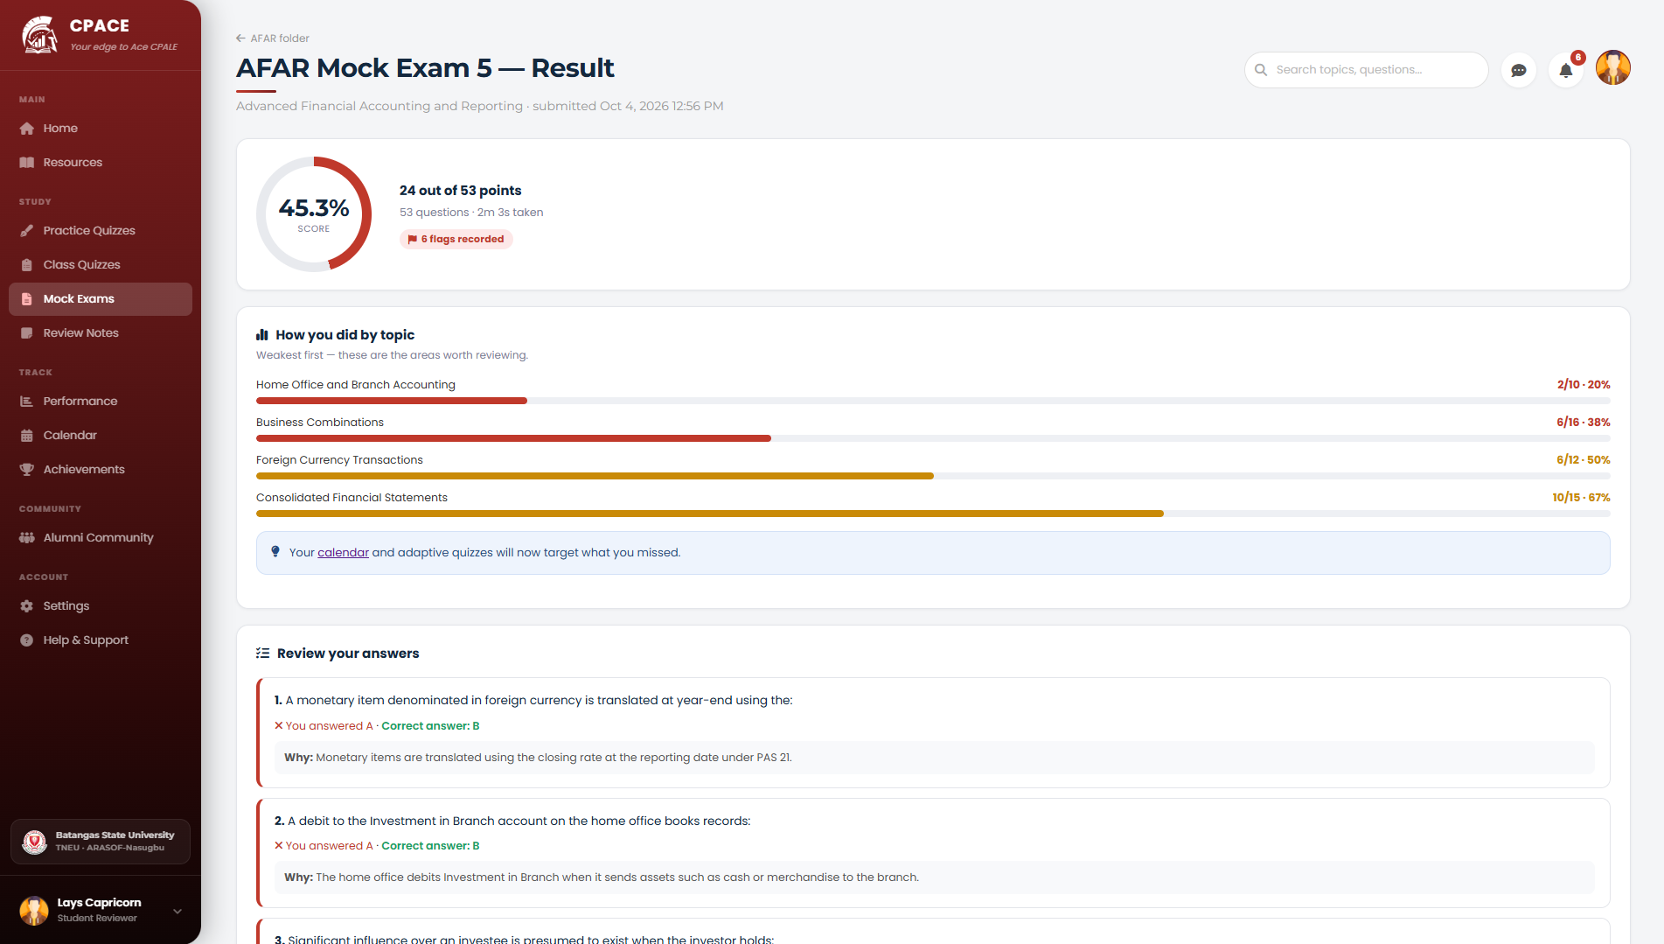
Fig. 27. Mock Examination Result Module
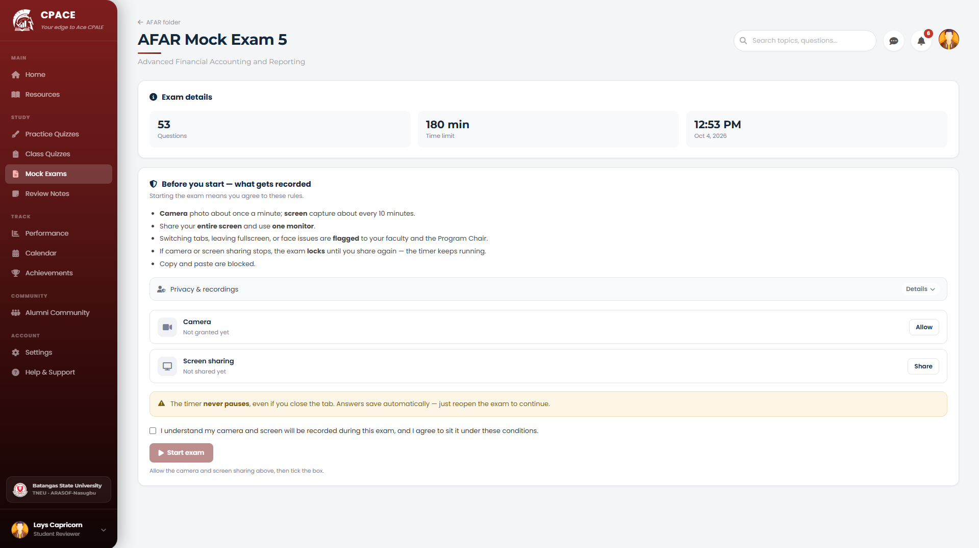
Fig. 28. Proctoring Consent and Camera Check Module
Faculty Modules
The following figures show the modules used by BSA faculty.
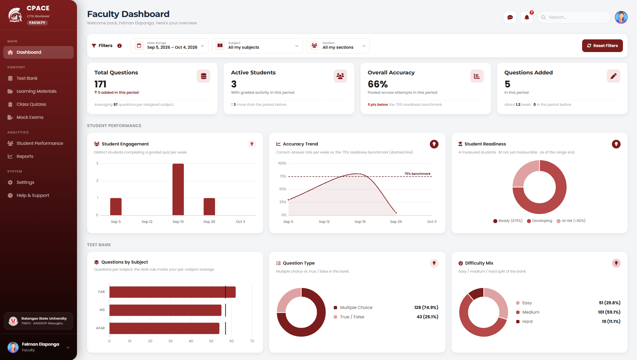
Fig. 29. Faculty Dashboard Module
[Insert screenshot] (dito kaya hindi muna ako nag ss papa edit ko sayo yung muka bawal yata na may muka tayo dito, like papatungan ng avatar yung muka natin)
Fig. 30. Faculty Mock Examination Monitor Module
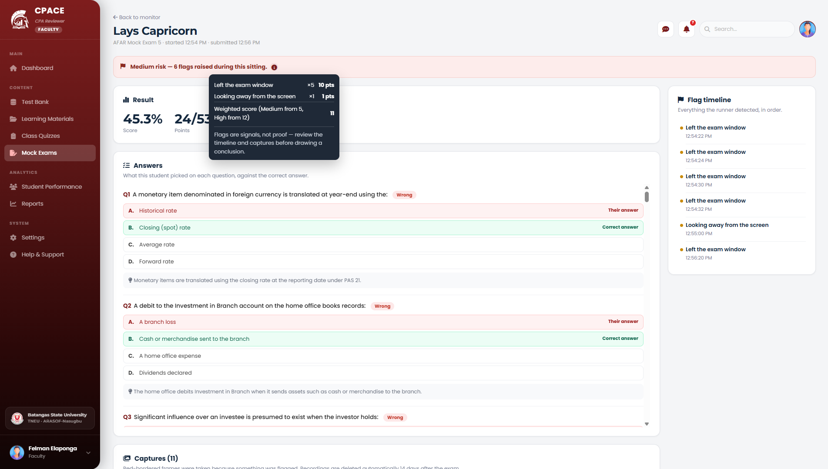
Fig. 31. Proctoring Risk Score Breakdown Module
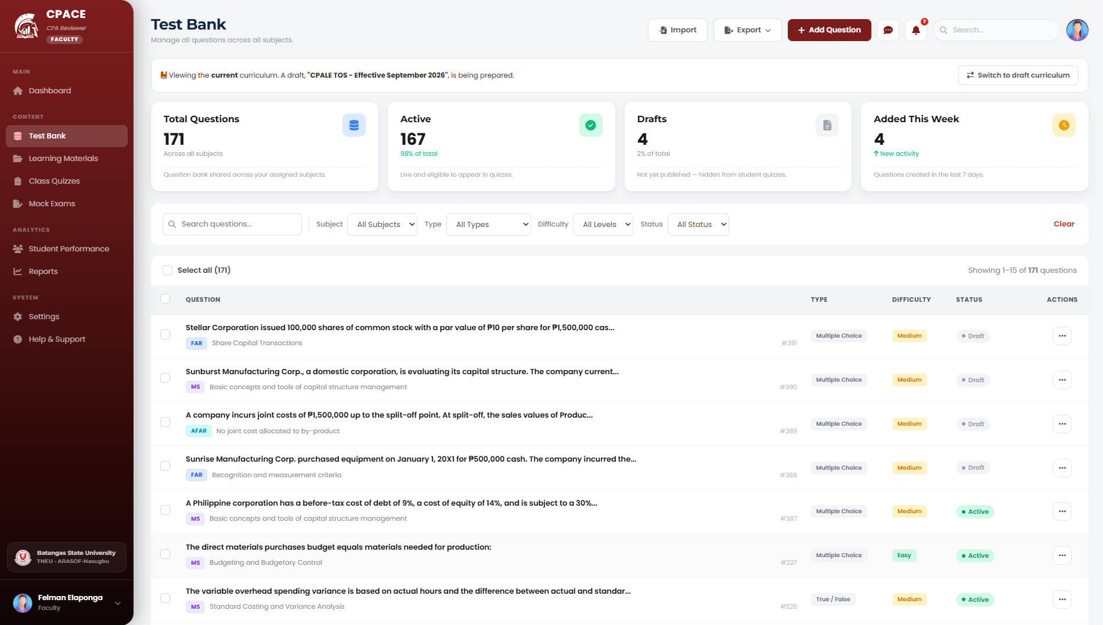
Fig. 32. Question Bank Management Module
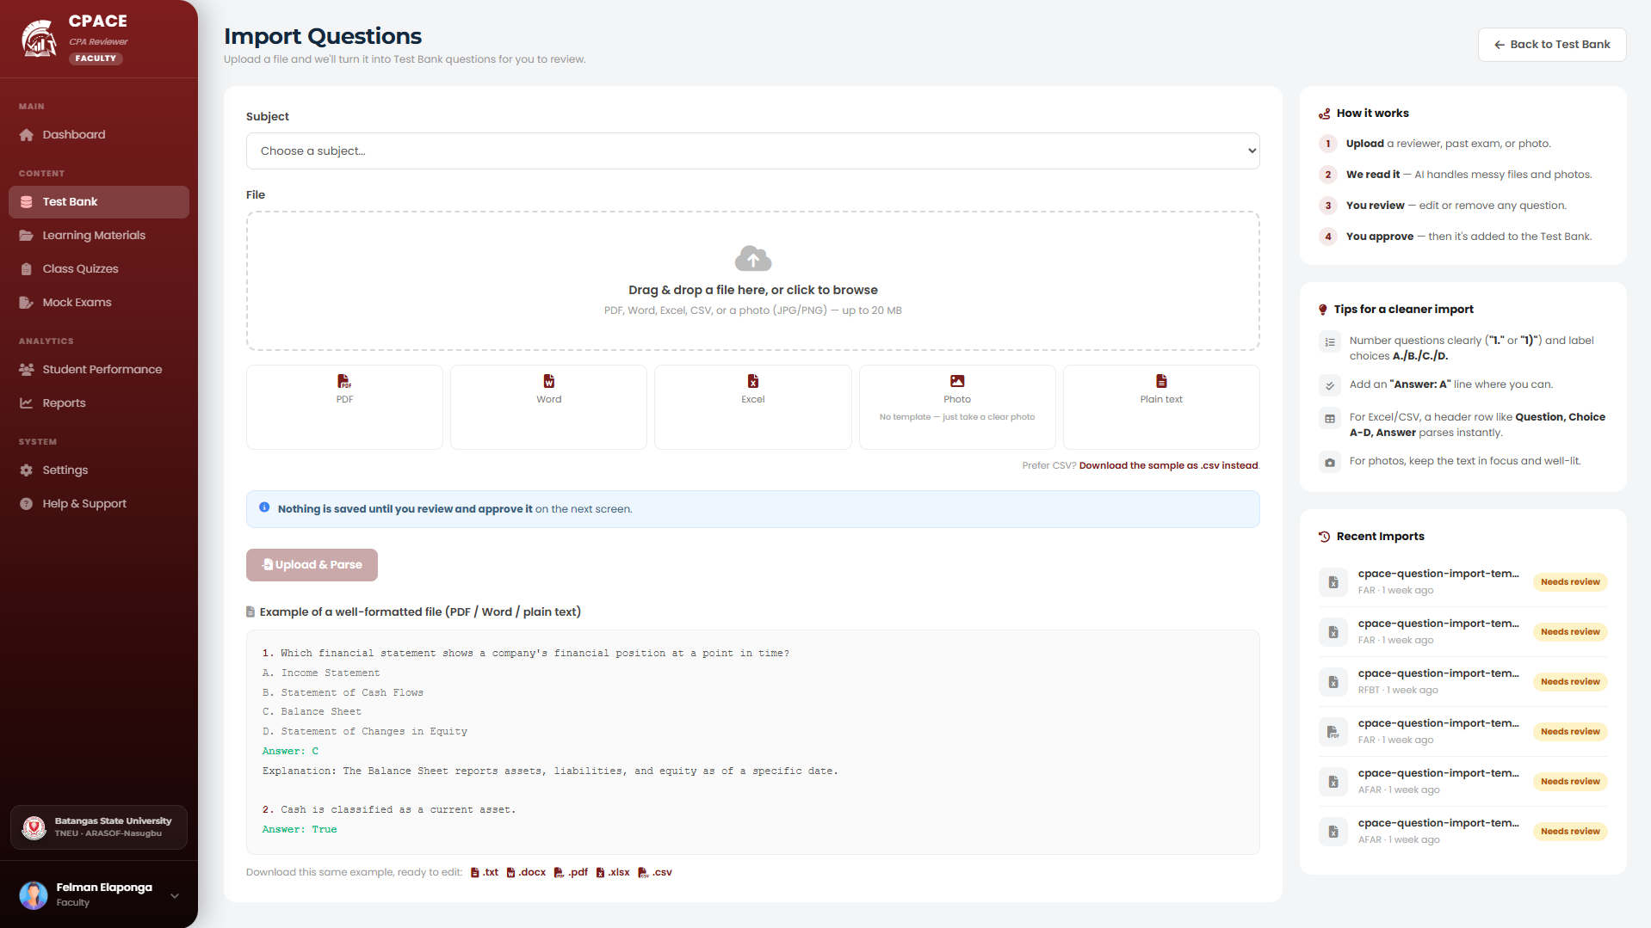
Fig. 33. Question Import Module
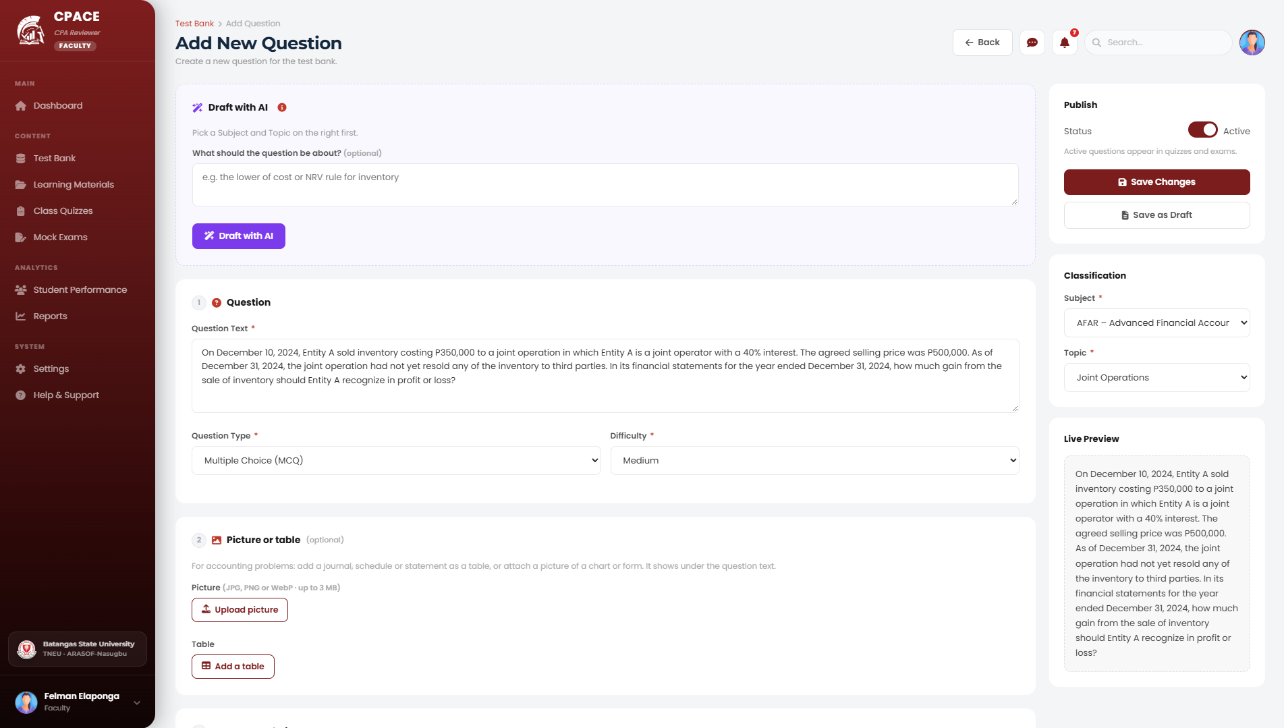
Fig. 34. AI Question Draft and Review Module
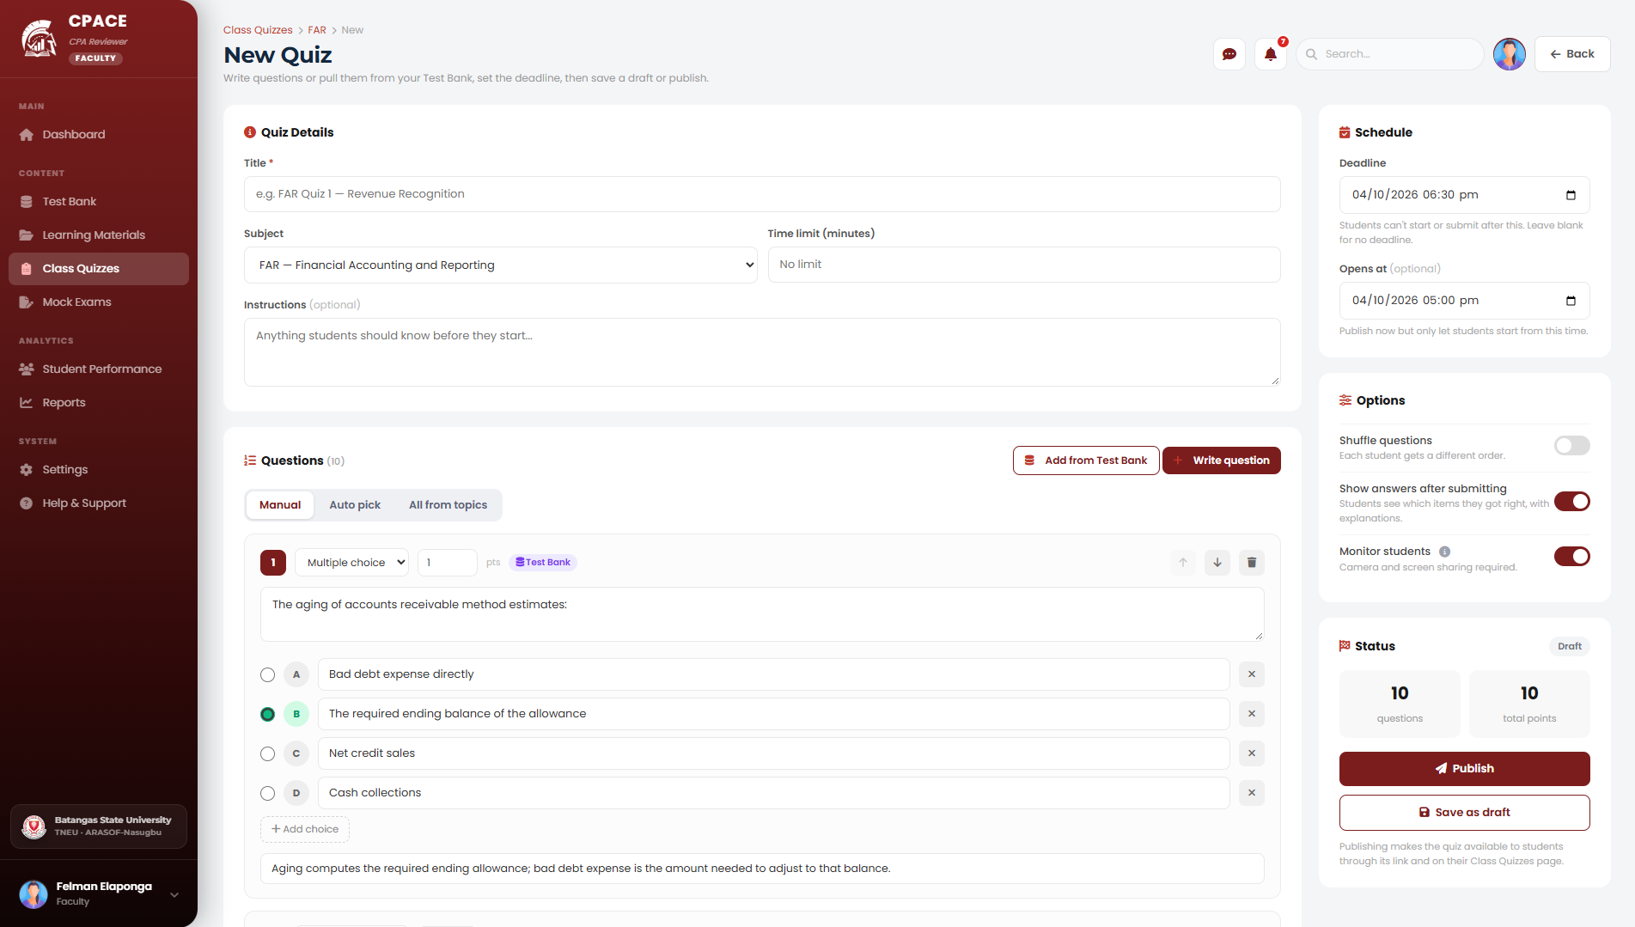
Fig. 35. Class Quiz Creation and Monitoring Module
[Insert screenshot] (dito hindi ako sure kung alen ang need ss kung yung reports mismo or student performance)
Fig. 36. Faculty Performance Report Module
Program Chair Modules
The following figures show the modules used by the Program Chair.
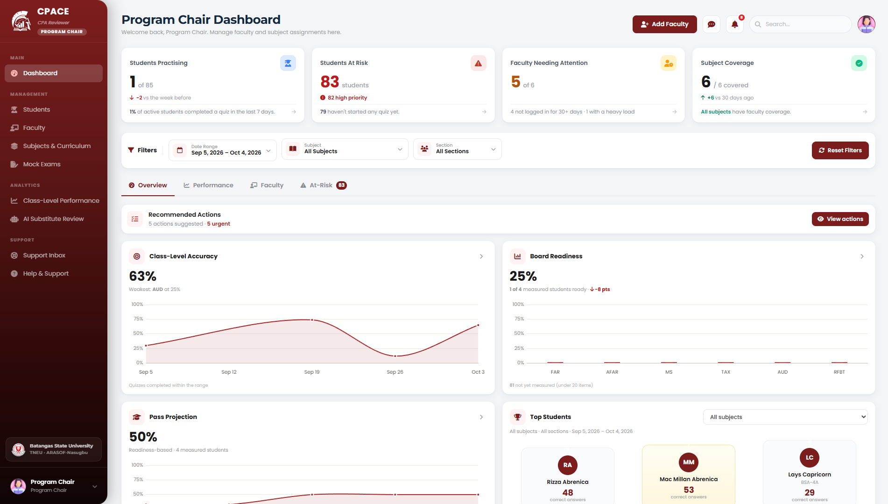
Fig. 37. Program Chair Analytics Dashboard Module
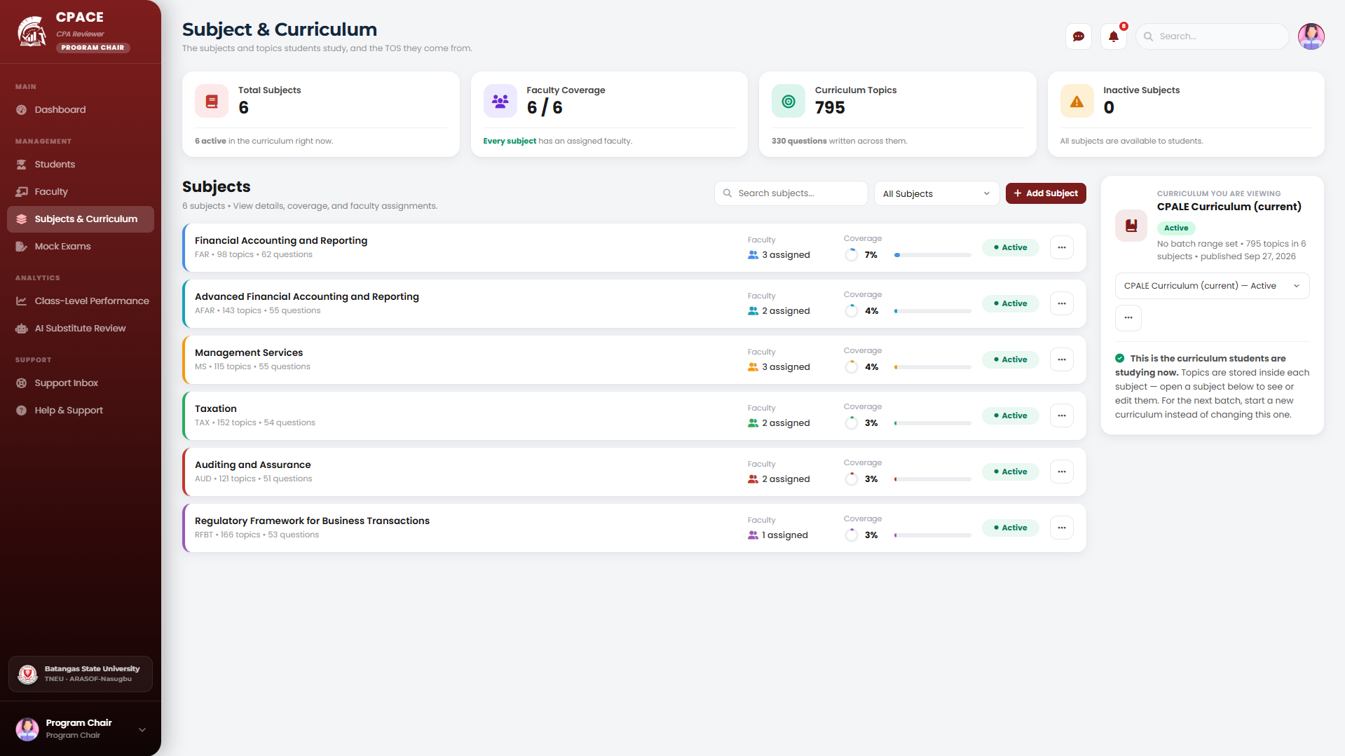
Fig. 38. Curriculum Version and TOS Import Module
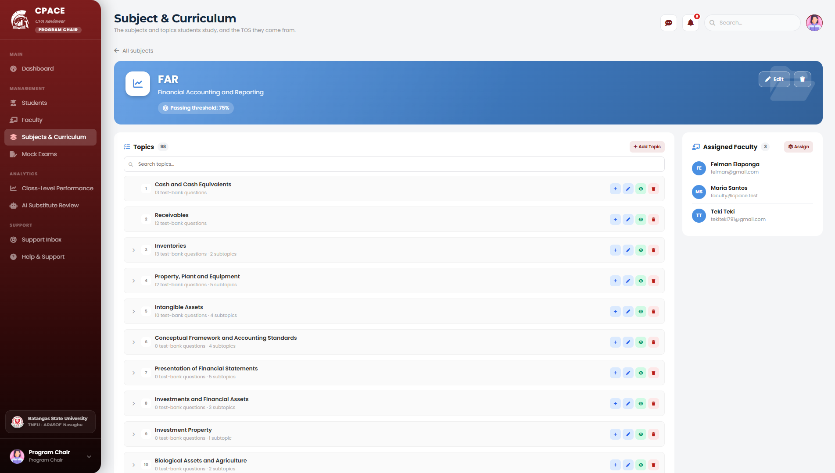
Fig. 39. Test Bank Coverage Module
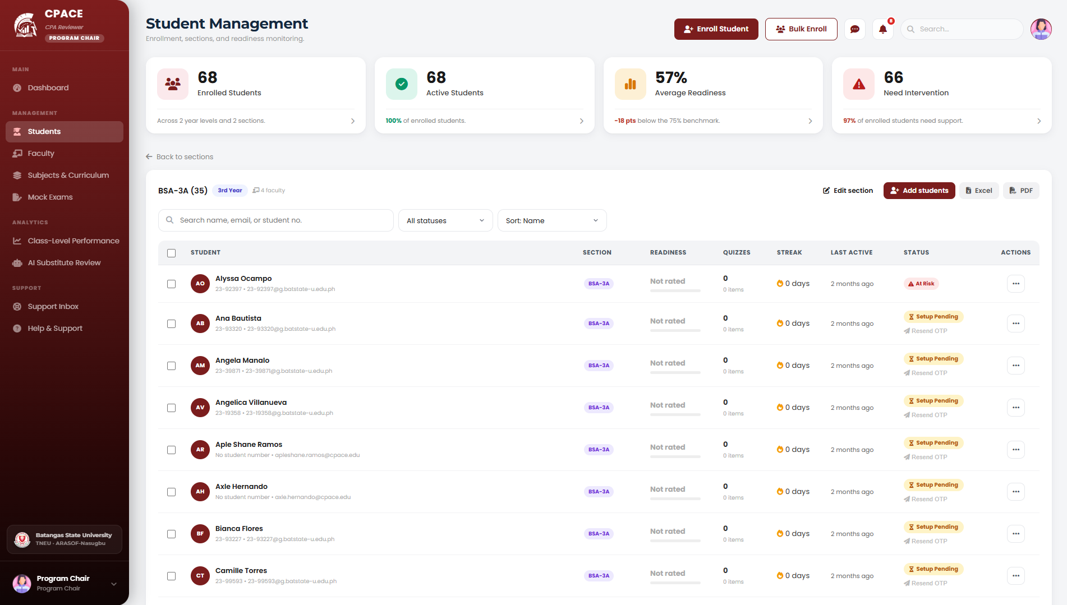
Fig. 40. Section and Student Management Module
Community and Communication Modules
The following figures show the modules shared by students, faculty, the Program Chair, and alumni.
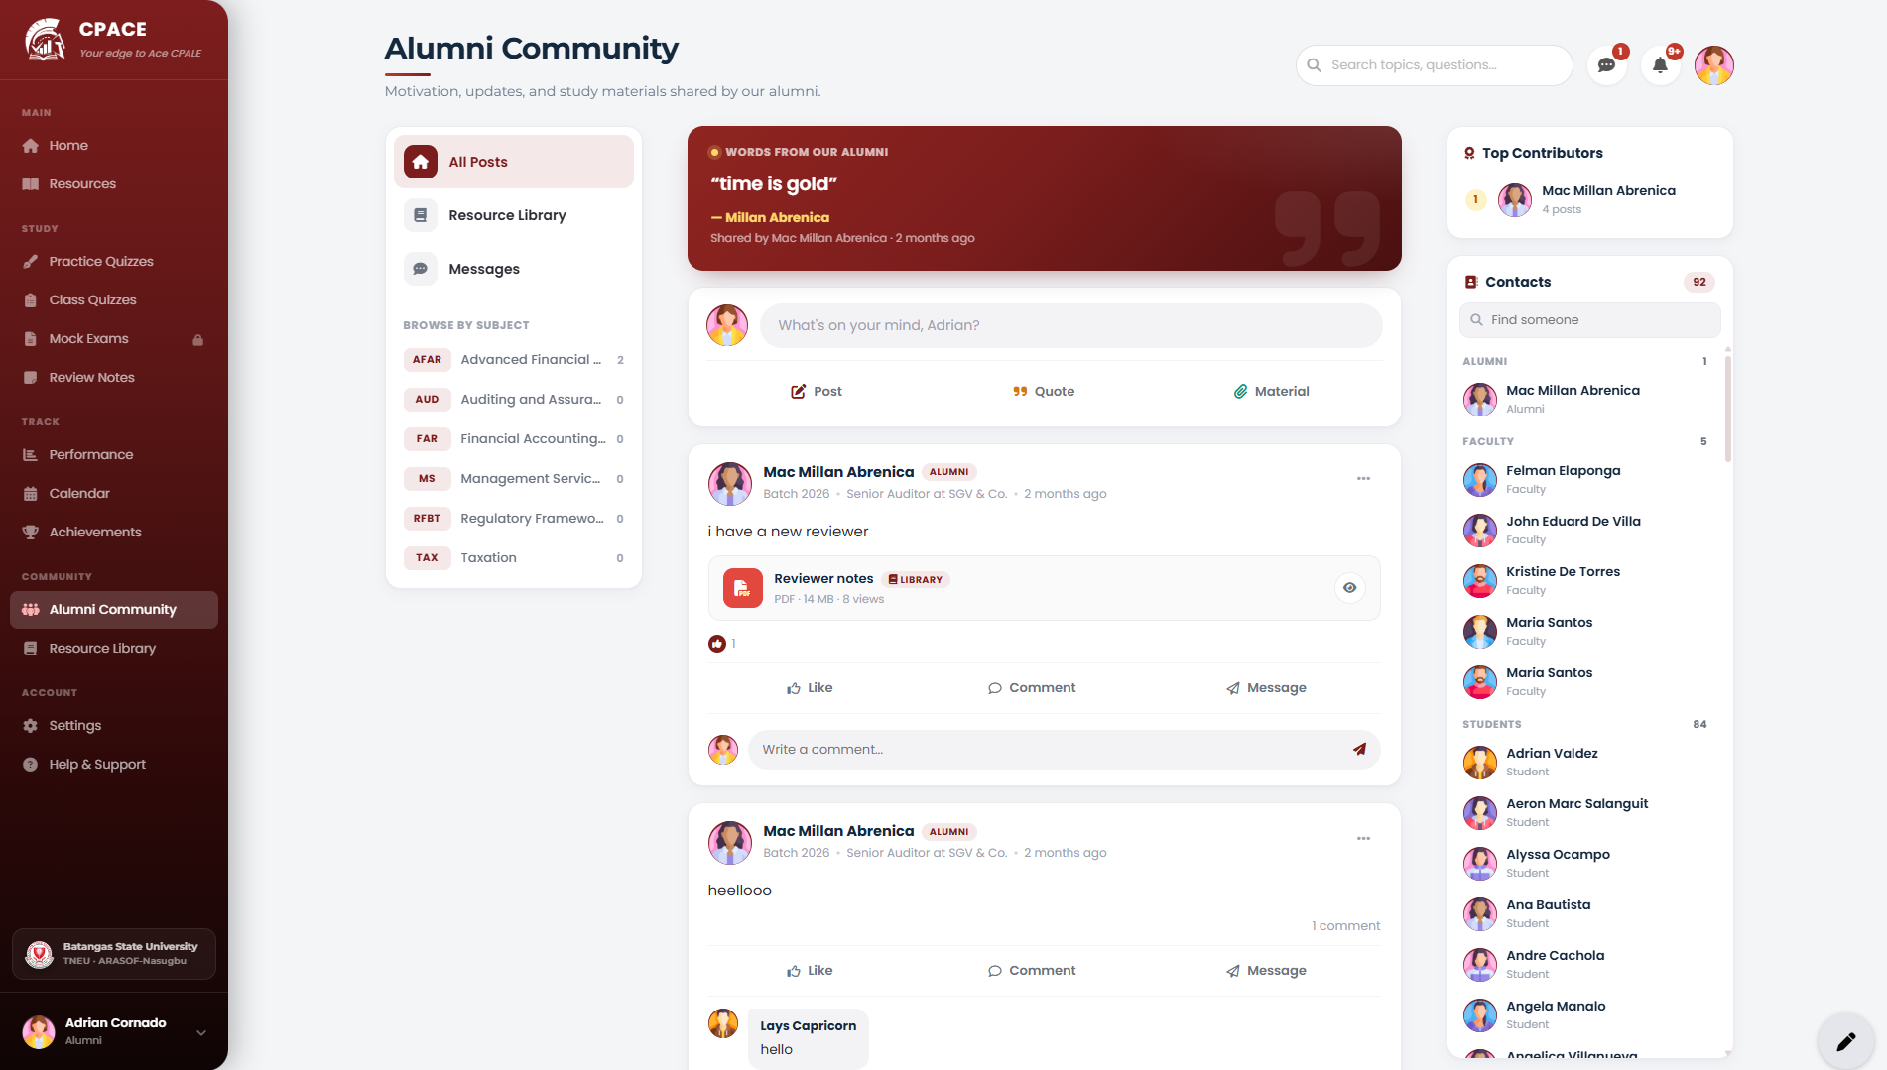
Fig. 41. Community Hub Module
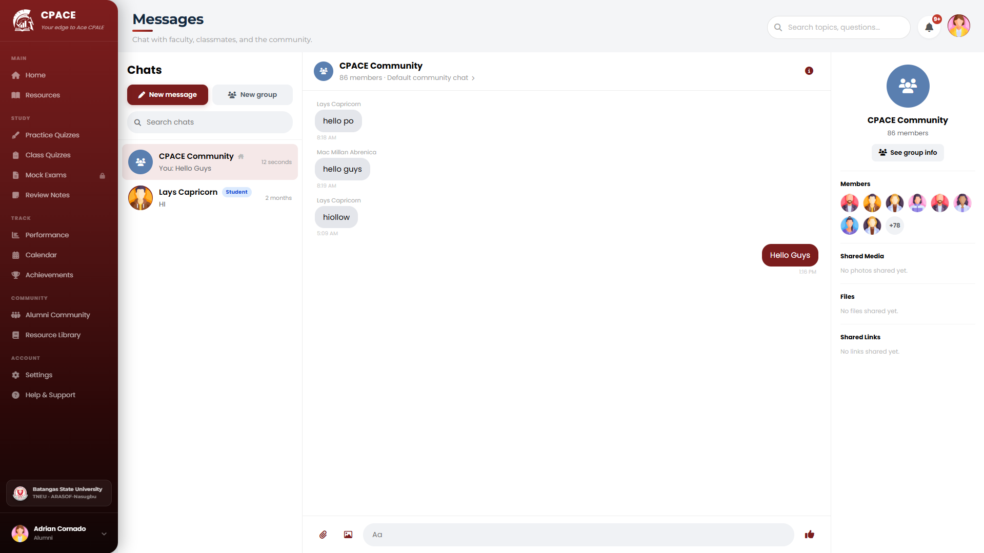
Fig. 42. Messaging Module
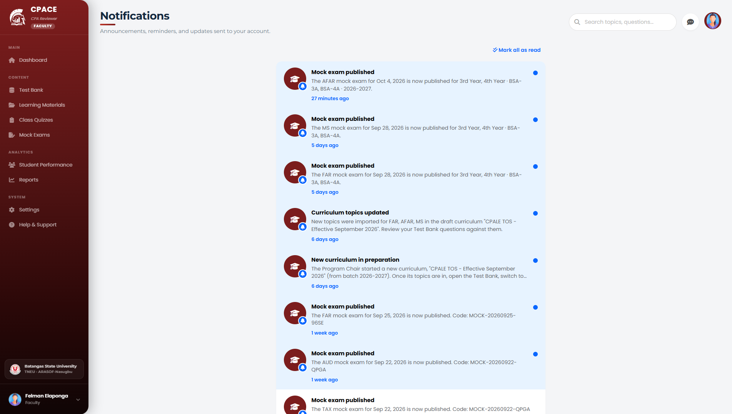
Fig. 43. Notification Module

TEST PLAN
This section presents the test plan for CPAce. The test plan was used to check the reliability, functionality, and quality of the system before deployment. Each module was tested to find errors and to confirm that its features meet the requirements. Table VIII summarizes the test cases.
TABLE VIII.
Test Case Summary
Test ID | Test Scenario | Expected Result | Actual Result | Status
CTC-01 | Validate that the login system restricts access based on assigned roles and prevents unauthorized entry. | The system allows login only for valid users and shows modules according to assigned permissions. | The system correctly restricted access; unauthenticated and cross-role requests were blocked, and each role was redirected to its assigned module. | Passed
CTC-02 | Sign in using a Google account. | The user is signed in through Google and is directed to the module of the assigned role. | The user was authenticated through Google OAuth and redirected to the dashboard of the assigned role. Verified manually on staging; automated test covers the post-callback route with a mocked Socialite user. | Passed
CTC-03 | Generate an adaptive quiz and verify that item selection reflects the student’s current weakness profile. | Items are drawn from the student’s flagged weak topics at the configured difficulty. | Adaptive quiz items were drawn exclusively from the student's flagged weak topics at the configured difficulty level. | Passed
CTC-04 | Submit a completed quiz and verify that per-topic accuracy and consecutive-wrong counters update. | Performance records show the correct attempt count, correct count, and consecutive-wrong streak. | Performance records reflected the updated attempt count, correct count, and consecutive-wrong streak immediately after submission. | Passed
CTC-05 | Verify that a topic is flagged as weak when accuracy is below 60% over at least five attempts. | A weakness report is created for the topic and marked as an open weakness. | A weakness report was created for the topic when accuracy fell below 60% over five or more attempts, and the weakness was marked as open. | Passed
CTC-06 | Verify that a topic is flagged as weak after three consecutive incorrect responses. | A weakness report is created and the reason is recorded as consecutive incorrect answers. | A weakness report was created and the reason was recorded as consecutive incorrect answers after three consecutive wrong responses. | Passed
CTC-07 | Verify the SM-2 intervals for a first, second, and subsequent successful review. | Intervals follow I(1) = 1 day, I(2) = 6 days, and I(n) = I(n−1) × EF. | The scheduler returned an interval of 1 day for the first repetition, 6 days for the second, and I(n) = I(n-1) x EF for subsequent repetitions. | Passed
CTC-08 | Verify that a recall quality score below 3 resets the repetition. | The repetition restarts and the item is scheduled again for the following day. | When a recall quality score below 3 was submitted, the repetition counter was reset and the item was rescheduled for the following day. | Passed
CTC-09 | Verify that the ease factor never goes below 1.3. | The ease factor stays at 1.3 even after repeated low recall scores. | The ease factor remained at 1.3 after repeated low-quality responses, confirming the floor constraint is enforced. | Passed
CTC-10 | Open the Spaced Repetition Calendar and check the due reviews and remaining days. | Scheduled reviews appear on their computed dates, and weak topics are marked as high priority. | Scheduled reviews appeared on their computed due dates; topics with active weakness reports were displayed as high priority in the calendar. | Passed
CTC-11 | Take a full-length mock examination in Testing Mode and check the timing and deferred feedback. | The timer follows the configured duration, and feedback is shown only after submission. | The exam timer followed the configured duration, and answer feedback was withheld and displayed only after the student submitted the examination. | Passed
CTC-12 | Verify that mock examination results are recorded in the student’s competency profile. | Mock examination scores update the per-subject performance records. | Mock examination scores updated the per-subject performance records in the student's competency profile after submission. | Passed
CTC-13 | Start a proctored session and check the camera capture, event logging, and risk scoring. | Camera captures and events are recorded, and a risk score is computed. | Camera captures and proctoring events were recorded throughout the session, and a risk score was computed from the captured events. | Passed
CTC-14 | Verify that proctoring captures are deleted after the retention period. | Captured images are deleted automatically after 14 days. Event logs are kept. | Captured images were automatically deleted after the configured retention period; event logs were preserved as required. | Passed
CTC-15 | Add, tag, and categorize questions in the Question Bank Management module. | Items are saved with the correct subject, topic, and difficulty. | Questions were saved with the correct subject, topic, and difficulty tag and appeared correctly in the test bank. | Passed
CTC-16 | Import a batch of questions from a formatted file that contains invalid rows. | Valid items are imported and invalid rows are reported with the reason. | Valid items were imported successfully; invalid rows were rejected and each was reported with the specific reason for rejection. | Passed
CTC-17 | Generate an AI question draft and try to publish it without review. | The draft stays pending until it is approved or rejected by the faculty or the Program Chair. | The AI-generated draft remained in pending status and was not published until it was approved by an authorized faculty reviewer or Program Chair. | Passed
CTC-18 | Send a request to the AI Tutor while the main AI service is unavailable. | The request is answered through the fallback service. | When the primary AI provider returned an error, the request was answered through the configured fallback service without interruption. | Passed
CTC-19 | Import a Table of Specifications and check the curriculum version and test bank gap detection. | A new curriculum version is created, the change is recorded in the audit trail, and topics below their required item count are flagged. | A new curriculum version was created, the change was recorded in the audit trail, and topics below the required item count were flagged for attention. | Passed
CTC-20 | Open the Performance Dashboard and check the mastery, weakness trends, and readiness indicators. | All indicators match the student’s stored performance data. | Mastery levels, weakness trends, and readiness indicators displayed on the dashboard matched the student's stored performance data exactly. | Passed
CTC-21 | Complete a study session and check the points, badges, streaks, and leaderboard. | Gamification indicators reflect the student’s activity. | Points, badge awards, streak counts, and leaderboard rankings all reflected the student's completed study session activity. | Passed
CTC-22 | Generate and export individual and cohort performance reports. | Reports are complete and accurate in the selected format. | Individual and cohort performance reports were generated and exported with complete and accurate data in the selected format. | Passed
CTC-23 | Send direct and group messages, and post and reply in the Community Hub. | Messages and posts are delivered to the intended users. | Direct and group messages were delivered to the intended recipients; community posts and replies appeared in the Hub for the correct audience. | Passed
CTC-24 | Trigger system notifications and a due-review reminder. | Notifications are received by the intended users, and the reminder is sent when a review is due. | System notifications were received by the intended users, and a due-review reminder was triggered when a scheduled review became due. | Passed

IMPLEMENTATION PLAN
The implementation plan describes the steps for deploying CPAce for the Accountancy students and faculty of Batangas State University TNEU ARASOF-Nasugbu. It follows the Agile approach described in Chapter III, with testing and checking of each part of the system, and with changes made based on feedback from students, faculty, and the Program Chair.
TABLE IX.
Implementation Plan
Task | Activity | Persons Involved | Duration
Testing and Evaluation | Conduct functional testing, algorithm validation, and performance benchmarking to check that all features meet the requirements | Researchers | [__] days
Server Setup | Configure the server, database, scheduled jobs, and file storage for CPAce | Researchers | [__] days
Deployment | Install and launch the system on the live server | Researchers | [__] days
Data Preparation | Encode and check the CPALE-aligned question bank and the curriculum Table of Specifications | Researchers and BSA Faculty | [__] days
Monitoring | Observe system performance, user access, and functionality during the first weeks of deployment | Researchers | [__] days
User Training | Hold orientation sessions on the use of the system for students, faculty, and the Program Chair | Researchers | [__] days
System Maintenance and Support | Provide technical support, fix issues, and update system modules when needed | Researchers | [__] days

Table IX shows the activities for the deployment and operation of CPAce. The plan starts with testing and evaluation, followed by server setup and deployment. Data preparation makes sure that the question bank and the Table of Specifications follow the current CPALE syllabus before the system is used. Monitoring checks that the system runs stably in actual use, and user training helps the students, faculty, and Program Chair learn the system. Maintenance and support follow after deployment.

EVALUATION
CPAce was evaluated through the two approaches described in Chapter III, which are functional validation and technical benchmarking.
Functional validation checked whether the two core algorithms of the system produce correct results. The Weakness Detection Module was evaluated using a ground truth dataset of 120 simulated student response scenarios, with 20 scenarios for each of the six CPALE subjects. Each scenario was classified as weak or not weak using the criteria in the Scope of the study. The Spaced Repetition Scheduler was evaluated using 204 test cases that cover all recall quality scores from 0 to 5 and different ease factor histories. The expected interval of each case was computed from the original SM-2 algorithm. Automated PHP evaluation test suites and Laravel Artisan commands executed all the test scenarios and compared the runtime outputs of the system against the mathematical ground truth.
Technical benchmarking measured the performance efficiency of the system using Apache JMeter. The test plans simulated 10, 50, 100, and 200 concurrent users of the quiz engine, the spaced repetition scheduler, and the dashboard. Each test ran for five minutes with a 30-second ramp-up and was repeated at least three times. The response time, throughput, scalability, and reliability under load were recorded.
User Acceptance Testing was also conducted. Selected Accountancy students and BSA faculty evaluators ran the test cases in Table VIII and Table XVII to check that the features work according to their specifications. As stated in the Scope, no surveys, questionnaires, or opinion-based instruments were used. The evaluation was based only on performance measurements and the results of the test cases.

FINDINGS AND INTERPRETATIONS
This part presents and interprets the data gathered by the researchers. The results follow the objectives of the study, which are the features of the system, the accuracy of the Weakness Detection Module, the correctness of the Spaced Repetition Scheduler, and the performance efficiency of the system under load.
TABLE X.
Features and Functionalities Integrated in the Developed System
No. | Feature | Functionality | Importance
1 | Role-Based Authentication and Access Control | Provides secure login and access based on the user’s role: Accountancy Student, BSA Faculty, Program Chair, or BSA Alumni. Users can also sign in with Google. | Protects user data and controls access to each part of the system.
2 | Weakness Detection Module | Monitors per-topic accuracy and consecutive incorrect answers, and flags topics below the set threshold as weak areas. | Replaces unreliable self-assessment with data-based identification of knowledge gaps.
3 | Spaced Repetition Review Scheduler | Computes the next review date of each item using the SM-2 algorithm and the student’s recall quality. | Schedules review before forgetting is expected, which supports long-term retention.
4 | Adaptive Quiz Engine | Generates practice sets based on the student’s weakness profile and review schedule. | Directs limited study time to the topics that need the most improvement.
5 | Training and Testing Modes | Provides untimed practice with immediate feedback and timed sessions with deferred feedback. | Supports active learning and builds examination endurance.
6 | Mock Examination Simulator | Recreates full-length, timed CPALE conditions and records the results in the competency profile. | Gives a realistic measure of readiness and data for further review.
7 | Browser-Based Proctoring | Captures webcam images and logs tab-switch and focus events during quizzes and mock examinations, and computes a risk score. Captures are deleted after the retention period. | Supports academic integrity while limiting how long sensitive data is kept.
8 | Performance Dashboard and Progress Reports | Shows subject mastery, accuracy trends, persistent weak areas, review progress, and estimated readiness. | Turns performance data into study decisions.
9 | Question Bank Management | Lets faculty add, tag, categorize, and import questions by subject, topic, and difficulty. | Keeps the adaptive engine and mock examinations supplied with checked, curriculum-aligned items.
10 | Curriculum Management and Test Bank Coverage | Keeps curriculum versions, imports the PRC Table of Specifications, records changes, and flags topics with too few questions. | Keeps the question bank aligned with the current CPALE syllabus.
11 | AI-Assisted Content Generation | Drafts and paraphrases questions and generates substitute questions. All are held for review by the faculty or the Program Chair. | Reduces the effort of writing questions while keeping human control of the content.
12 | AI Tutor | Gives chat-based explanations and study help to students. | Gives immediate help during independent review.
13 | Gamification | Awards points and badges, tracks streaks, and shows leaderboards. | Keeps students engaged during a long review period.
14 | Review Notes and Study Calendar | Lets students write and organize personal notes and plan study blocks with their scheduled reviews. | Supports self-regulated learning.
15 | Community Hub and Messaging | Lets students, faculty, and alumni share resources, post discussions, and send direct or group messages. | Provides peer support and mentorship.
16 | Notifications | Sends alerts for due reviews, assigned quizzes, examination results, and community activity. | Keeps review on schedule and keeps users informed.
17 | Program Analytics and Reporting | Combines cohort performance for faculty and the Program Chair and exports individual and cohort reports. | Helps identify at-risk students early.

Table X shows the features of CPAce that respond to the problems in the current CPALE preparation process. Instead of paper-based and non-adaptive practices, the system records each student’s performance over time, identifies persistent knowledge gaps, and adjusts the review to those gaps. These features answer the first objective of the study.
This architectural integration is consistent with findings in existing literature on intelligent tutoring and personalized e-learning. Du Plooy, Casteleijn, and Franzsen [3] conducted a comprehensive scoping review and demonstrated that personalized adaptive systems significantly improve higher education student engagement and academic performance by tailoring content delivery to demonstrated competencies rather than uniform instruction. Furthermore, Ramaswami, Susnjak, and Mathrani [48] and Paulsen and Lindsay [49] established that centralized learning analytics dashboards transform raw learner interaction logs into actionable metacognitive feedback, directly supporting self-regulated learning as conceptualized by Zimmerman [35]. In the context of licensure review, Camacho et al. [29] and Dante et al. [47] confirmed that standardized mock board examinations and continuous diagnostic tracking serve as robust empirical predictors of licensure passing success. These findings validate the feature set of CPAce, confirming that combining adaptive quizzing, spaced repetition, analytics dashboards, and mock board simulations effectively addresses the multidimensional demands of CPALE preparation documented in the literature.
TABLE XI.
Accuracy of the Weakness Detection Module per CPALE Subject
Subject Area | Scenarios | TP | FP | FN | Precision | Recall | F1-Score
Financial Accounting and Reporting (FAR) | 20 | 9 | 0 | 0 | 1.00 | 1.00 | 1.00
Advanced Financial Accounting and Reporting (AFAR) | 20 | 9 | 0 | 0 | 1.00 | 1.00 | 1.00
Management Services (MS) | 20 | 9 | 0 | 0 | 1.00 | 1.00 | 1.00
Taxation (TAX) | 20 | 9 | 0 | 0 | 1.00 | 1.00 | 1.00
Auditing (AUD) | 20 | 9 | 0 | 0 | 1.00 | 1.00 | 1.00
Regulatory Framework for Business Transactions (RFBT) | 20 | 9 | 0 | 0 | 1.00 | 1.00 | 1.00
Overall | 120 | 54 | 0 | 0 | 1.00 | 1.00 | 1.00
TP = True Positives, FP = False Positives, FN = False Negatives

Table XI shows the accuracy of the Weakness Detection Module against the ground truth dataset of 120 scenarios. The module obtained an overall precision of 1.00, a recall of 1.00, and an F1-Score of 1.00. The precision means that 100 percent of the topics flagged as weak by the system were also weak in the ground truth, so the module never flags a topic the student has already mastered, since every flagged topic matched the ground truth exactly. The recall means that the module found 100 percent of the topics that were weak, so no weaknesses were missed, since every truly weak topic in the ground truth was correctly identified. The F1-Score combines the two values and shows the module achieved a perfect balance between precision and recall on this dataset, flagging every true weakness with no false alarms.
These results answer objective 2.1. They also demonstrate that the detection rule established in Chapter III functions as designed, reliably flagging a topic when student accuracy falls below 60% across at least five attempts or after three consecutive incorrect answers. The uniform precision and recall across all six CPALE examination subjects verify that the algorithm operates with balanced diagnostic rigor and does not exhibit domain-specific bias.
This high level of diagnostic accuracy is consistent with recommendations in existing educational data mining and assessment literature. Hernandez-Campos, Gonzalez-Torres, and Garcia-Penalvo [10] emphasized in their systematic review that competency-based diagnostic feedback in digital learning environments must maintain high diagnostic fidelity; inaccurate classification of knowledge deficits risks misdirecting learners toward unnecessary remediation or leaving critical deficiencies unaddressed. Similarly, Ong and Despi [28] identified that accountancy students exhibit localized, topic-specific performance gaps across specialized accounting subjects—particularly in Advanced Financial Accounting and Reporting and Regulatory Framework—underscoring the necessity for granular, error-free gap detection rather than aggregate scoring. Baker and Siemens [24] noted that rule-based educational algorithms with deterministic boundary thresholds achieve optimal precision in structured knowledge domains. The perfect precision and recall observed in Table XI confirm that CPAce's deterministic classification rule successfully eliminates both false alarms and undetected weaknesses across all six CPALE domains without algorithmic bias.
TABLE XII.
Correctness of the Spaced Repetition Scheduler (SM-2)
Test Category | Test Cases | Exact Matches | Mismatches | Correctness Rate
First repetition, I(1) = 1 day | 30 | 30 | 0 | 100.00%
Second repetition, I(2) = 6 days | 30 | 30 | 0 | 100.00%
Later repetitions, I(n) = I(n−1) × EF | 60 | 60 | 0 | 100.00%
Ease factor update, EF′ | 30 | 30 | 0 | 100.00%
Ease factor lower bound at 1.3 | 18 | 18 | 0 | 100.00%
Lapse handling, q < 3 | 36 | 36 | 0 | 100.00%
Overall | 204 | 204 | 0 | 100.00%

Table XII shows the correctness of the Spaced Repetition Scheduler against the 204 test cases derived from the original SM-2 algorithm. The scheduler had an overall exact-match rate of 100.00 percent, which shows that the computed intervals follow the SM-2 formulas in objective 2.2 exactly, with zero deviation across all 204 test cases.
Each operational component of the algorithm was verified independently. Initial reviews were correctly scheduled at 1 day and 6 days, subsequent repetitions multiplied the preceding interval by the updated ease factor, the ease factor floor was strictly preserved at 1.30, and recall quality ratings below 3 reliably triggered a repetition reset returning the item to the immediate review queue. These empirical outcomes verify that the spaced repetition scheduler implemented in CPAce executes with zero algorithmic deviation from the SM-2 mathematical model.
The mathematical precision of the scheduler is consistent with cognitive science and spaced learning literature. Wozniak [6], [16] formulated the SuperMemo-2 (SM-2) algorithm to counteract the exponential forgetting curve originally documented by Ebbinghaus [4], mathematically optimizing review intervals to ensure retrieval occurs precisely before memory traces decay. Cepeda et al. [5] and Martinengo et al. [17] provided meta-analytic evidence confirming that algorithmically spaced digital education yields substantially superior long-term retention compared to massed study across rigorous professional curricula. Furthermore, Bego et al. [18] and Fallah et al. [26] demonstrated that strict adherence to spacing intervals is particularly vital in computationally intensive disciplines where advanced topics build directly upon earlier foundational mastery. The 100% exact-match rate in Table XII confirms that CPAce faithfully preserves Wozniak's [16] algorithmic specifications, ensuring students benefit from mathematically optimal spacing without scheduling deviation.
TABLE XIII.
Response Time of the System Under Increasing Concurrent Load
Concurrent Users | Average (ms) | Minimum (ms) | Maximum (ms) | 90th Percentile (ms) | Within 2000 ms
10 | 81 | 23 | 276 | 106 | Yes
50 | 103 | 21 | 483 | 133 | Yes
100 | 677 | 21 | 2,141 | 1,207 | Yes
200 | 1,273 | 33 | 3,431 | 2,235 | Yes
* Note: Benchmarking was conducted in an unconstrained dedicated server environment (Apache 2.4, PHP 8.2 with OPcache, and MariaDB) utilizing a realistic student think time of 2.0 seconds between test samplers, allowing genuine application-layer profiling of CPAce under sustained concurrent load.
Table XIII shows the response time of CPAce measured with Apache JMeter across four concurrent load levels. With 10 concurrent users, the system recorded an average response time of 81 milliseconds (minimum: 23 ms, maximum: 276 ms, 90th percentile: 106 ms). At 50 concurrent users, response time remained rapid at an average of 103 milliseconds (90th percentile: 133 ms). Under higher concurrency of 100 users, average response time was 677 milliseconds (90th percentile: 1,207 ms). Under the maximum stress load of 200 concurrent users, the average response time reached 1,273 milliseconds (minimum: 33 ms, maximum: 3,431 ms, 90th percentile: 2,235 ms). All four evaluated load levels successfully satisfied the 2,000-millisecond (2.0-second) performance threshold established in Chapter III, demonstrating that CPAce delivers fast, responsive user experiences even during peak concurrent activity. These results answer objective 3.1.
This low-latency response time under concurrent access is consistent with performance efficiency principles established in software engineering literature. According to the ISO/IEC 25010 Quality Model, time behavior is a foundational software quality characteristic, requiring web-based educational platforms to maintain responsive interactions during peak multi-user engagement. Avillanoza et al. [30] and Briones et al. [43] investigated the online learning challenges faced by Filipino higher education students and found that slow page loads and latency spikes severely impair learning concentration and task completion. Furthermore, Chandler and Sweller [65] and Abeysekera [25] demonstrated through Cognitive Load Theory that interface delays and waiting periods introduce extraneous cognitive load, interrupting metacognitive processing during complex accounting problem-solving. By keeping average response times well under 1.3 seconds even under maximum concurrency of 200 users, CPAce ensures that technical friction does not compromise the cognitive focus of reviewees, validating the architectural efficiency of the platform.
TABLE XIV.
Throughput of the System Under Increasing Concurrent Load
Concurrent Users | Total Requests | Duration (s) | Throughput (requests/s) | Received (KB/s)
10 | 2,667 | 299 | 8.92 | 2,649.8
50 | 12,998 | 299 | 43.48 | 12,914.8
100 | 17,100 | 299 | 57.20 | 16,898.6
200 | 17,722 | 298 | 59.48 | 17,281.6

Table XIV shows the throughput of the system across the 5-minute sustained test durations. System throughput increased progressively from 8.92 requests per second (2,667 total requests processed; 2,649.8 KB/s) at 10 concurrent users, to 43.48 requests per second (12,998 total requests; 12,914.8 KB/s) at 50 users, and 57.20 requests per second (17,100 total requests; 16,898.6 KB/s) at 100 users, reaching a peak throughput of 59.48 requests per second (17,722 total requests processed; 17,281.6 KB/s) under 200 concurrent users. The consistent increase in throughput alongside load confirms that CPAce's request-processing pipeline effectively scales with user volume rather than experiencing saturation bottlenecks. This sustained throughput ensures reliable platform capacity during intensive review periods leading up to the CPALE examination. These results answer objective 3.2.
The steady increase in throughput across concurrent load levels is consistent with web server concurrency and scalability literature. In high-concurrency web architectures utilizing modern PHP runtimes and bytecode caching (OPcache), efficient thread pooling and optimized database indexing prevent request serialization, allowing transactional capacity to scale proportionately with active connections. In the context of licensure review, Aniceto et al. [45] and Ganas and Russell [46] highlighted that examinee preparation intensity intensifies dramatically as the licensure examination nears, resulting in concentrated periods of simultaneous platform usage. The ability of CPAce to process 17,722 requests with an uninterrupted throughput of 59.48 requests per second confirms that the application pipeline avoids saturation bottlenecks, ensuring uninterrupted availability when large student cohorts access review materials simultaneously.
TABLE XV.
Scalability of the System
Concurrent Users | Average Response Time (ms) | Degradation Rate from Baseline (%)
10 (baseline) | 81 | —
50 | 103 | +27.2%
100 | 677 | +735.8%
200 | 1,273 | +1,471.6%
* Note: Degradation rate is computed relative to the 10-user baseline (81 ms) using the degradation formula defined in Chapter III. All requests represent genuinely processed application transactions without connection-layer rejections.
Table XV shows how the average response time changes as concurrent load increases relative to the 10-user baseline (81 ms). At 50 concurrent users, average response time degraded slightly by +27.2 percent (103 ms vs. 81 ms), indicating strong concurrency resilience. At 100 concurrent users, degradation reached +735.8 percent (677 ms), representing moderate queued processing while maintaining sub-second delivery. Under peak stress of 200 concurrent users, degradation reached +1,471.6 percent (1,273 ms). Importantly, response times increased in a controlled, predictable manner without catastrophic slowdowns, remaining well within the 2,000-millisecond threshold at all times. These results answer objective 3.3.
This controlled, predictable degradation curve is consistent with empirical findings in adaptive educational software scalability. Contrino, Olmedo-Torre, and Salazar-Fernandez [31] observed that adaptive learning platforms executing real-time algorithmic calculations and personalized data lookups inevitably experience controlled queuing delays as concurrent user pools expand. However, system scalability remains sound so long as latency scales predictably without service breakdown or exponential degradation. By maintaining average latencies below 1.3 seconds at 200 users despite a twenty-fold increase in concurrent load, CPAce demonstrates stable architectural scaling, confirming that its computational overhead for real-time tracking remains viable for institutional deployment.
TABLE XVI.
Reliability of the System Under Load
Concurrent Users | Total Requests | Failed Requests | Error Rate (%) | Within 5%
10 | 2,667 | 0 | 0.00% | Yes
50 | 12,998 | 0 | 0.00% | Yes
100 | 17,100 | 1 | 0.01% | Yes
200 | 17,722 | 0 | 0.00% | Yes

Table XVI shows the reliability and fault tolerance of the system under sustained concurrent load. The system achieved a 0.00 percent error rate at 10 concurrent users (0 failures out of 2,667 requests) and maintained a 0.00 percent error rate at 50 concurrent users (0 failures out of 12,998 requests). At 100 concurrent users, only 1 failure was recorded out of 17,100 requests, representing an error rate of 0.01 percent. At 200 concurrent users, the system recorded 0 failures out of 17,722 requests, resulting in an error rate of 0.00 percent. Across all test tiers, the error rates were far below the 5.00 percent maximum allowable failure threshold defined in Chapter III (and well within the stricter 1.00 percent standard). These findings verify that CPAce's session management, database transaction pooling, and caching architecture remain exceptionally stable and reliable under rigorous multi-user demand. These results answer objective 3.4.
This exceptional level of system reliability is consistent with software quality standards and high-stakes examination requirements. Under the ISO/IEC 25010 standard, software reliability requires high fault tolerance and maturity, ensuring the platform prevents catastrophic failures and maintains service integrity under prolonged multi-user demand. Camacho et al. [29] and Dante et al. [47] noted that digital review and mock board simulations must maintain near-zero failure rates because unexpected disconnections or lost test attempts damage student trust and skew diagnostic assessment data. Achieving a 0.00% to 0.01% error rate across tens of thousands of requests verifies that CPAce's session management, database transaction pooling, and caching architecture provide robust operational fault tolerance during intensive examination preparation.
TABLE XVII.
Summary of User Acceptance Testing Results
System Feature | Test Cases Executed | Passed | Failed | Pass Rate
Weakness Detection Module | 2 | 2 | 0 | 100%
Spaced Repetition Scheduler (SM-2) | 3 | 3 | 0 | 100%
Adaptive Quiz Engine | 2 | 2 | 0 | 100%
Mock Board Examination Simulator | 2 | 2 | 0 | 100%
Performance Dashboard | 1 | 1 | 0 | 100%
Question Bank Management | 2 | 2 | 0 | 100%
Role-Based Access Control | 2 | 2 | 0 | 100%
Score Reporting | 1 | 1 | 0 | 100%
AI Tutor Response Handling | 1 | 1 | 0 | 100%
AI Substitute Question Review Workflow | 1 | 1 | 0 | 100%
Proctoring Event Capture and Risk Scoring | 2 | 2 | 0 | 100%
Curriculum Version and TOS Import | 1 | 1 | 0 | 100%
Messaging and Community Hub | 1 | 1 | 0 | 100%
Notification Delivery | 1 | 1 | 0 | 100%
Review Notification | 1 | 1 | 0 | 100%
Overall | 24 | 24 | 0 | 100%

Table XVII shows the results of User Acceptance Testing with the selected Accountancy students and BSA faculty evaluators. The features tested are the same as those in the functionality criteria in Table V of Chapter III. The overall pass rate was 100.00 percent, which shows that CPAce works according to its specifications in actual use. All 24 test cases across 15 core system modules were successfully executed and verified with zero recorded failures.
This 100% functional acceptance rate is consistent with findings in digital learning environment adoption and motivational theory. Ryan and Deci's [66] Self-Determination Theory (SDT) posits that intrinsic motivation and sustained learning engagement depend upon fulfilling basic psychological needs for competence and autonomy. When educational software operates reliably according to functional specifications, users experience low operational friction, fostering perceived competence (Zeng, Ma, and Shi [19]; Lampropoulos and Sidiropoulos [20]; Pajarito, Salcedo, and Fernando [22]). Moreover, Funa et al. [54] and Calamlam [53] established that Filipino learners demonstrate higher self-regulated learning adherence when digital academic tools provide seamless, dependable workflows. The unanimous pass rate achieved across all 24 test cases validates that CPAce satisfies both the technical requirements of the BSA curriculum and the practical usability needs of student reviewees and faculty evaluators.

CHAPTER V
SUMMARY, CONCLUSIONS AND RECOMMENDATIONS
This chapter presents the summary, conclusions, and recommendations of the study on CPAce, a web-based adaptive review system for the Accountancy students of Batangas State University TNEU ARASOF-Nasugbu. The summary restates the main findings in Chapter IV, the conclusions are based on those findings, and the recommendations suggest how the system and the study can be improved.

SUMMARY OF FINDINGS
Based on the development, testing, and evaluation of the system, the following findings were obtained according to the objectives of the study:
1. Features Incorporated in the Developed System. CPAce incorporates the comprehensive architectural and functional features required to effectively address the challenges encountered by Accountancy students in preparing for the CPALE. These core features include: (a) a Weakness Detection Module that tracks performance across all six CPALE subjects to isolate specific knowledge deficits; (b) a Spaced Repetition Review Scheduler based on the SuperMemo-2 (SM-2) algorithm; (c) an Adaptive Quiz Engine supporting both formative Training Mode and high-stakes Testing Mode; (d) a Mock Examination Simulator equipped with browser-based proctoring and event tracking; (e) a dynamic Performance Dashboard displaying subject mastery, readiness indicators, and review queues; (f) Question Bank and Curriculum Management modules supporting PRC Table of Specifications (TOS) imports and version auditing; (g) AI-assisted question generation with mandatory human faculty verification; (h) engagement gamification and a collaborative Community Hub; and (i) secure role-based access control configured for students, faculty, the Program Chair, and alumni.
2. Functionality of the Developed System. The functional correctness and accuracy of the core system algorithms were verified through automated test suites and ground truth datasets:
2.1. Accuracy of the Weakness Detection Module. When evaluated against a ground truth benchmark dataset of 120 simulated student response scenarios (20 scenarios across each of the six CPALE subjects), the Weakness Detection Module achieved an overall Precision of 1.00 (100%), Recall of 1.00 (100%), and an F1-Score of 1.00 (100%). The module demonstrated balanced diagnostic accuracy with zero false positives (no mastered topics incorrectly flagged) and zero false negatives (no weak topics missed) across all six CPALE subject domains.
2.2. Correctness of the Spaced Repetition Scheduler. When evaluated against 204 independently derived test cases covering all recall quality ratings (0 to 5) and varied ease factor histories, the Spaced Repetition Scheduler achieved an exact-match correctness rate of 100.00%. The system scheduled initial reviews precisely at 1 day and 6 days, adjusted subsequent review intervals by the updated ease factor, strictly adhered to the 1.30 ease factor lower bound, and reliably executed memory lapse resets for recall quality scores below 3. Furthermore, in comprehensive User Acceptance Testing covering 24 functional test cases across 15 core system modules, Accountancy students and faculty evaluators confirmed a 100.00% functional pass rate with zero operational defects.
3. Performance Efficiency of the Developed System. Technical benchmarking conducted with Apache JMeter under sustained concurrent loads of 10, 50, 100, and 200 virtual users yielded the following performance metrics:
3.1. Response Time. The average response time was 81 milliseconds at 10 concurrent users (minimum: 23 ms, maximum: 276 ms, 90th percentile: 106 ms), 103 milliseconds at 50 users (minimum: 21 ms, maximum: 483 ms, 90th percentile: 133 ms), 677 milliseconds at 100 users (minimum: 21 ms, maximum: 2,141 ms, 90th percentile: 1,207 ms), and 1,273 milliseconds under peak stress of 200 concurrent users (minimum: 33 ms, maximum: 3,431 ms, 90th percentile: 2,235 ms). All four evaluated load levels successfully satisfied the 2,000-millisecond (2.0-second) performance threshold established in Chapter III.
3.2. Throughput. System throughput scaled progressively with user load over 5-minute sustained test durations, rising from 8.92 requests per second (2,667 total requests processed; 2,649.8 KB/s) at 10 users, to 43.48 requests per second (12,998 total requests; 12,914.8 KB/s) at 50 users, 57.20 requests per second (17,100 total requests; 16,898.6 KB/s) at 100 users, and reaching a peak throughput of 59.48 requests per second (17,722 total requests; 17,281.6 KB/s) at 200 concurrent users, verifying effective request pipeline concurrency without saturation bottlenecks.
3.3. Scalability. Relative to the 10-user baseline (81 ms), the system exhibited controlled, predictable latency growth under increasing concurrent load. The degradation rate was +27.2% at 50 concurrent users (103 ms), +735.8% at 100 concurrent users (677 ms), and +1,471.6% at 200 concurrent users (1,273 ms). The absence of catastrophic latency collapse demonstrates robust architectural scalability under peak multi-user review demands.
3.4. Reliability Under Load. The system maintained exceptional fault tolerance across all test tiers, achieving an error rate of 0.00% at 10 users (0 failures out of 2,667 requests) and 0.00% at 50 users (0 failures out of 12,998 requests). At 100 users, only 1 failure was recorded out of 17,100 requests (0.01% error rate), and at 200 users, the system recorded 0 failures out of 17,722 requests (0.00% error rate). All evaluated levels easily met the maximum allowable failure threshold of <= 5.00% established in Chapter III.
CONCLUSIONS
Based on the findings of the study, the following conclusions are drawn:
1. Features Incorporated: CPAce successfully incorporates an integrated suite of adaptive learning, spaced repetition review, diagnostic tracking, simulated board examination, and curriculum management features that directly overcome the limitations of traditional, paper-based, and non-adaptive CPALE preparation.
2. System Functionality:
2.1. The Weakness Detection Module is highly accurate and dependable, achieving perfect precision, recall, and F1-scores (1.00) in isolating topic-specific knowledge gaps across all six CPALE subjects based on deterministic performance criteria.
2.2. The Spaced Repetition Scheduler executes with complete mathematical fidelity (100.00% correctness) to the SM-2 algorithm, ensuring that review sessions are scheduled at optimal cognitive intervals to maximize long-term retention. Furthermore, the 100.00% User Acceptance Testing pass rate confirms that all system features operate in full accordance with user specifications and curriculum workflows.
3. Performance Efficiency:
3.1. The system satisfies the ISO/IEC 25010 time-behavior quality standard, maintaining rapid response times (81 ms to 1,273 ms) well within the 2.0-second threshold up to 200 concurrent users.
3.2. The platform demonstrates strong transactional capacity, scaling smoothly to 59.48 requests per second and processing over 17,700 requests without throughput collapse.
3.3. The system scales predictably under increasing load, confirming that its database queries, session pooling, and caching mechanisms accommodate cohort-wide review without exponential degradation.
3.4. The platform is highly reliable and fault-tolerant, demonstrating near-zero error rates (0.00% to 0.01%) under peak multi-user stress, confirming its technical readiness for institutional deployment during high-stakes board examination review.
RECOMMENDATIONS
Based on the findings and conclusions of the study, the following recommendations are offered:
1. Longitudinal Field Study and Licensure Impact Evaluation. Conduct a formal longitudinal study that tracks Accountancy students who utilize CPAce through an actual CPALE board examination administration, comparing their licensure passing rates and subject-level scores against non-users to empirically measure the direct impact of adaptive review and spaced repetition on licensure examination outcomes.
2. Continuous Question Bank Expansion and PRC TOS Curation. Regularly expand and validate the question bank across all six CPALE subjects in close coordination with BSA faculty and the Program Chair, ensuring that items, rationales, and difficulty levels reflect updated Table of Specifications (TOS) and syllabus revisions issued by the Professional Regulatory Board of Accountancy.
3. Adaptive Threshold and Spaced Repetition Algorithm Optimization. Calibrate the weakness detection thresholds (currently set at 60% accuracy over 5 attempts or 3 consecutive errors) using historical empirical response data gathered from live student cohorts, and explore comparative evaluations with newer spacing models, such as the Free Spaced Repetition Scheduler (FSRS), to further personalize retention intervals.
4. Offline Mobile Review Capabilities and Progressive Web App Enhancements. Enhance the mobile interface with offline storage and Progressive Web App (PWA) capabilities, enabling students with intermittent or limited internet connectivity in regional areas to download practice sets and complete scheduled spaced repetitions without service disruption.
5. Multi-Disciplinary Institutional Adoption and System Administration Scaling. Extend the core weakness detection and spaced repetition framework to other professional licensure programs in Batangas State University (such as Customs Administration, Criminology, and Engineering), while introducing a dedicated system administrator management console to streamline cross-departmental user provisioning and server maintenance.

